Rosaryhill School

Old Students Association

RHSOSA Newsletter

Volume 2, 2006
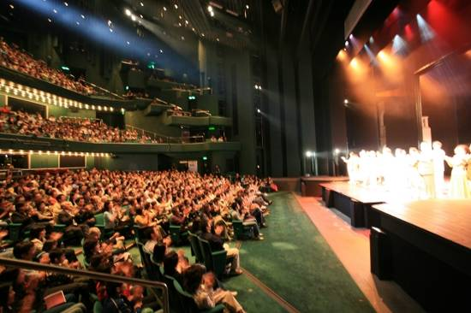
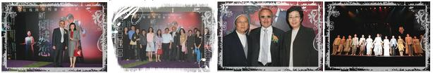
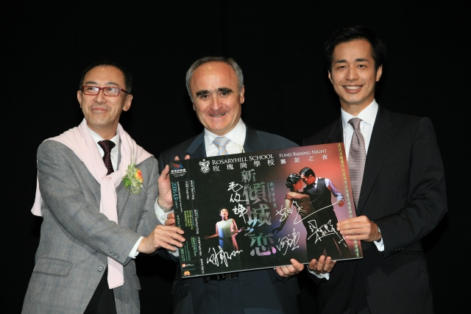

「戲劇之夜」
-
玫瑰崗學校
凝聚力量
This Volume:
- Love in a Fallen City
- An Interview with Mr. Tom Yu (Page 2 to 4)
- 2006 Farewell Dinner and Mah-jong Competition (Page 5).
The keynote event: “Love in a Fallen City (新傾城之戀)" of The 2005 Rosaryhill School Fund Raising programme started with sparkle of photo flashes. The theatre was filled with alumni, students, teachers, parents and staff. It was a night of glamour and art.

One of the performance of the Hong Kong Repertory Theatre’s drama production of “Love in a Fallen City" has been reserved exclusively for the purpose of the Rosaryhill School’s fund raising was held on 9 April 2006 at the Lyric Theatre of the Hong Kong Academy for Performing Arts (HKAPA).

We are delighted to say that two of the leading cast members, Mr. Leung Ka-fai Tony and Ms. Alice Lau, are past students of our school. Mr. Edward Lam, one of the script writers of the 2nd edition, is also our past student. Mr. Chan Kin Bun, the Executive Director of the Hong Kong Repertory Theatre, is an ex-RHS’s teacher.

Love in a Fallen City (新傾城之戀)

Volume 2, 2006
Page 2 of 5

An interview with Mr. Tom Yu

OSA: Mr. Yu, We understand that you were an old boy of RHS before you became a teacher and later the Deputy Principal. We really want to know more about your history in the School. We thought about researching this a bit, but believe that it will be even better to have the first hand story from you.

Mr. Yu: I started in September 1964 as a F.1 student of RHS, graduated as a F.7 student in 1971, worked as a lab assistant between 9/71 and 8/72, I then went to the University of HK for 3 years. Actually I worked as a teacher for one month in 9/72, substituted Mr. Stephen Tsai, who was with HK Olympic team in Munich – You know what happened that year, HK Olympic team was living next door to Israelis' team – that's another story. I came back to start my teaching career in 9/75, left RHS in 12/91, worked for University of Texas at Austin from 4/92 until now. During the first 40 years of my life, I've spent more than half of my time in the School – to be exact, 24 years and 4 months. I must say that I've considered RHS as my second home.

OSA: Wow…our teacher was in the Olympic team and was a wall’s length to the massacre….Mr. Yu, Would you please share with us your recent development. Being with the School for that long and also a key leader here before your departure, how do you like the days without us and the School around?

Mr. Yu: After leaving HK in Jan 1992, my wife and I moved to Austin, Texas. We both were able to find jobs at the University of Texas at Austin. I worked in the Office of Admissions / Registrar's Office of the University. I've been with different job titles, Computer Programmer, System Analyst, Senior System Analyst and the present title is Senior Operating Systems Specialist. Even I'm still working in an education institute; my role is now technical instead of educational. As I've said, the School is my second home, and will always be. I missed my family, my mother, my brother, my sister and my second home: RHS. I always tried to find time to be with my family. Every time I went back to HK for vacation, I always tried to spend time with the Fathers and the teachers of the school.

OSA: How would you describe the changes in our School in the past 10 (or 20) years? Do you like the changes?

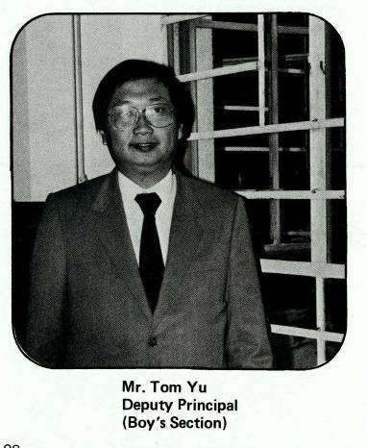

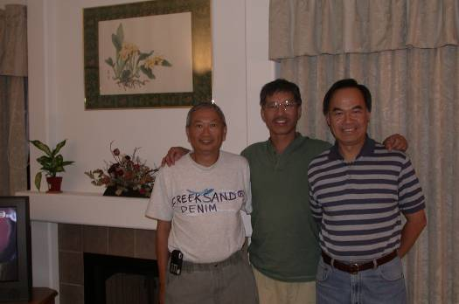
“I've spent more than half of my time at the School – to be exact, 24 years and 4 months.”

Mr. Tom Yu on the far left, Mr. Patrick Lung and Mr. Lawrence Leung

Page 3 of 5
Volume 2, 2006

An interview with Mr. Tom Yu (Continued)
Mr. Yu: When I first started as a student in 1964, the building had just opened for one year, and the school had classes up to F.3. We had 8 classes of F.1 (4 classes of boys and 4 classes of girls). I cannot recall how many classes of F.2 and F. 3, but will say there were less than 600 students. As I started my teaching career in 1975, there were about 1,200 students. At that time, the school was still privately owned. We had limited resources, but a very nice environment and we could keep the general standard of the students to a level that we were comfortable with. With fewer students, it was easier to manage.

In 1980, the school was changed to a government subsidy secondary, with other sections (Kindergarten, Primary and Commercial) still private. With this big change, the school got more resources, but had to take in more students (much more than we wanted), and could only have 40% direct feed of students from our Primary. I think that's a big lost to the Secondary section and also to our Primary section. With 53 classes when I left the school in 1990 (later up to a max of 55 classes), and nearly 2000 students and 83 teachers (just in the Secondary section), and three other sections in the same building, we did have problems with students, teachers and other sections.

After I left, I'm glad that number of classes had reduced, number of students dropped and even more resources from the government. However, I still have questions about the teaching media, but I'm not in the position of giving any comment because I'm out of the loop.

OSA: Mr. Yu, I share your view – the change into a government subsidy secondary school probably is still a topic of debate in many reunions of old boys and girls. Yet, we know that all the leaders and teachers in the School are doing their best to foster a better tomorrow.

When I drafted the questions, I had a theme of “An Educator with a View” in my mind. We have been constantly hearing the criticism that youngsters nowadays lack some strength, such as perseverance and adaptability, as compared to those in the past generations. What is your opinion on this? As a seasoned educator, what do you think as a youth, a parent, or a teacher should do to improve the trend?

Mr. Yu: Before I answer your questions, I have to say that I'm not an "Educator" any more. (May be I'm not an educator after all, I can only say that teaching is my career for 16 years and 4 months). May be you should consider changing the theme because I'm off the loop for 14 years and don't have a deep inside view of education in HK.

It will be unfair for me to say anything about youngsters because I'm not in HK and for the past 14 years, I only have 4 visits, less than 40 days in HK. I did have some information from newspaper, TV news, but cannot rely on these to comment. This is a good question for Mr. Robert Kwan, Ms Cathy Lau, Mr. Daman Chan and Ms. Kitty Ho.

OSA: Yes. We’ve got a question for next interview with Ms Lau. Could you share with us a few 1) fun occasions, 2) memorable moments and 3) champion cases in your teaching career at our School?

Mr. Yu: Fun occasions: I remember one day a teacher (Ms Amy Lo) approached me saying that some students in a F.2 Class were very happy to see me SMILING. :-) I asked myself "Am I so bad?" I thought that I was funny. Today, my co-worker told me that "You are always smiling no matter how bad the situation is".

Memorable moments: I remembered when I first approached Fr. Xavier and Fr. Salas for funding to buy computers and built a computer network in 1985 to improve the efficiency of administrative work, they just got what I wanted without questioning my ability. Luckily everything worked out. I never missed any deadline of printing name sheet for all classes, student ID card of all students before the start of the school year, printing of test result sheets and report cards and calculation of final grades.

OSA: Mr. Yu told us his champion case but asked us not to publish it. I am taking the liberty of revealing it here (My apology, Mr. Yu.) In the year 1989-90 when Mr. Yu was teaching Physics to F.7 students, the A-level exam result was great – I would omit the grades herein, but I have to say it was really outstanding. Mr. Yu is just being too modest, saying that he didn’t want to take the credit, which should go to his students. Surely, an outstanding teacher can make a big difference. And surely, Mr. Yu, I doubt whether I had seen you smile at all. (Mr. Yu is very kind to send us his recent photo with a big smile!).

Getting back to the interview, Mr. Yu, if you can start it all over, would you still go into teaching career? Why? If yes, is there any area that you want to do more or do less to make it even more perfect?

Mr. Yu: I've a mixed feeling about this question. On one hand, I would like to teach others with what I know and very happy to know that they got something from me. On the other hand, the education system in HK had been in such a situation that a teacher cannot do his/her job freely and cannot 100% concentrate on teaching. I'll say no with the present situation in HK.

OSA: Could you please give some words of remarks to the teachers, alumni and students of the School.

Mr. Yu: I grew up at the School, spent most of my time in the School and RHS is my second home and you are my brothers and sisters. If you like to contact me, feel free to email me at tom.yu@austin.utexas.edu With 2009 approaching, our classmates (1969 F.5 Grad.) is planning for a home coming and hope to see you at the School.

OSA: Zillion thanks for your time and energy. This interview is my first assignment after I joined the OSA committee last month. I need to admit that I was quite disconnected from the School in the past 20+ years, too busy climbing the corporate ladder. You really make this interview so delightful and….easy. (The interview was done via email, i.e., Mr. Yu wrote out all the elaborated replies – my work was…minimal!)

Reporter: Monica Cheung Mok,

An interview with Mr. Tom Yu (Continued)
Page 4 of 5
Volume 2, 2006

2006 Farewell Dinner and Mahjong Competition

Page 5of 5
Volume 2, 2006

We are organising a Farewell Dinner for a number of retired/retiring teachers including Ms So Choi Yin and Mr. Thomas Pak and our secondary school principal Fr. Francisco. To make the event more entertaining, RHSOSA will organise our 1st Mah-jong Competition; there will be a cash prize of HK$1000 for the Winner, the King / Queen of Mah-jong, of the Mah-jong Competition 2006!!!
Details of the event are as follows:
Date: 29th July 2006
Time: 4:30pm to 10:30pm
Venue: Foo Lum Fisherman's Wharf Restaurant
at Shun Tak Centre in Sheung Wan
Price: $400 (Mah-jong Competition
+ OSA Dinner)
$300 (OSA Dinner Only for adult /child)
Programmes:
- Mah-jong competition
- Lucky Draw
- Games
- Slideshows
- Karaoke
To make reservation, please make payment into our HSBC Savings Account No. 002-0-191581 and e-mail us your name, contact phone and the reference number on your pay-in-slip to vfp811@yahoo.com.hk or call Jacky Chan at 9348-8780 on or before 24th July 2006.
We look forward to seeing you soon!
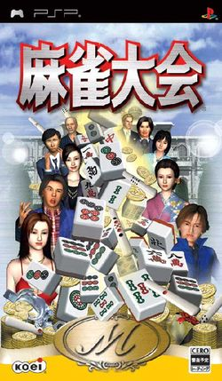

RHSOSA Newsletter Volume 2, 2006

We’re on the Web!
See us at:
www.rhsosa.org
Rosaryhill School Old Students Association

41B Stubbs Road, Wanchai, Hong Kong.

Email:
editorial@rhsosa.org

Rosaryhill School Old Students Association
41B Stubbs Road, Wanchai, Hong Kong.
http://rhsosa.org

Editorial Board:
Edward Ng
Patrick Rozario
David Chow
Monica Cheung Mok

