Rosaryhill School

Old Students Association

RHSOSA Newsletter

Issue 4,

March 2006
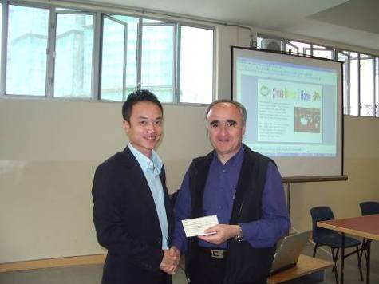
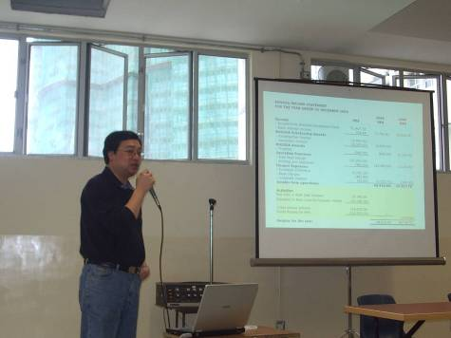
"The outgoing President, Mr. Eric Lee … presented the 2005 annual report. It was an exciting year … "
This Issue:
- 2006 RHSOSA Annual General Meeting
- New RHSOSA President's Address
- New RHSOSA Honorary Member
- Love on a Fallen City (新傾城之戀)
Another year went by quickly; it is time again for our Annual General Meeting (AGM). The 2006 AGM of the Rosaryhill Old Student Association (RHSOSA) was held on 11 March 2006 at 3:00 p.m. in the new Auditorium of Rosaryhill School (RHS).

The outgoing President, Mr. Eric Lee and the Treasurer, Mr. David Chow presented the 2005 annual report. It was an exciting year, the RHSOSA hold a Pui-Choi Fund Raising for the South Asian Tsunami; we launched the RHSOSA Scholarship Awards for the Secondary Section and the Kindergarten Section in 2005; and last but not least, as part of the 2005 Rosaryhill School Fund Raising programme, the RHSOSA organized the X'mas dinner @ Home in the School.

On behalf of the 2005 RHSOSA Executive Committee, Eric thanked the RHSOSA's members for their support and the 2005 committee resigned from their posts.

Then, the nominees of the 2006 RHSOSA Executive Committee Office Bearers were announced. The attending RHSOSA members unanimously accepted the new 2006 RHSOSA Executive Committee Office Bearers. Mr. Edward Ng was elected as the 2006 President of RHSOSA.

The minutes of 2005 AGM can be found in the rhsosa.org website.

2006 RHSOSA Annual General Meeting

Mr. Eric Lee
Our outgoing President with Fr. Francisco de las Heras
Mr. David Chow
The Treasurer reported the 2005 financial status

RHSOSA Newsletter #4
Page 2 of 4

New RHSOSA President's Address

Our newly elected President, Mr Edward Ng was a graduate in 1980's. Edward spent 13 years and completed his primary and secondary education in our alma mater. This is not the first time that Edward serves the RHS community. Edward is also the Chairman of 2005 Rosaryhill School Fund Raising Committee.

As Edward said in his inauguration speech, "Together with the new 2006 RHSOSA Executive Committee, I wish that RHSOSA could provide a channel for all Rosaryhill School's old students to stay in touch with our alma mater and our old friends so that the Rosarian family will become bigger and stronger".

In addition to Edward as President and Fr. Francisco de las Heras as Honorary President, the 2006 RHSOSA Executive Committee includes the following members:

Ms. Cathy Lau – Honorary Member
Ms. Kitty Ho – Deputy Principal (RHS)
Ms. Amy Chan – Vice-President
Mr. David Chow - Treasurer
Mr. Henry Lim - Secretary
Ms. Lydia Lau – Membership
Ms. Dorothy Lai – Information Technology
Mr. Patrick Rozario – Editorial
Ms. Evy Cheung – Finance
Mr. Jacky Chan – Event & Activities
Mr. Raymond Lok – Public Relation
Mr. Wilson Kwok

The 2006 RHSOSA Executive Committee is looking forward to in helping to bring all past students, current students and the school in closer contact. As Edward said "I am looking forward to seeing the participation and closer ties of our alumni with the larger RHS community of past students, teachers, staff and parents".

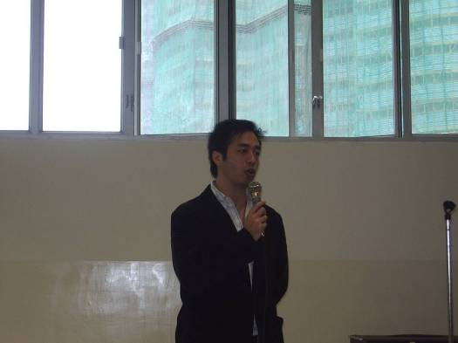

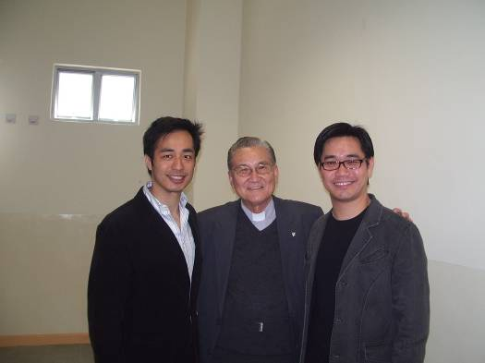
“RHSOSA could provide a channel for all Rosaryhill School's old student to stay in touch with our alma mater and our friends .. ”

Edward, Fr. Lionel Xavier and another old student in the AGM.
Mr. Edward Ng
Our new President giving his inauguration speech

Page 3 of 4
RHSOSA Newsletter #4

New RHSOSA Honorary Members – Ms. Cathy Lau

We are very pleased to announce that during the 2006 AGM, the RHSOSA members had unanimously accepted the nomination of the 2005 RHSOSA Executive Committee for Ms. Cathy Lau to become an Honorary Member of RHSOSA and Ms. Lau has accepted the invitation.

Ms. Cathy Lau is no stranger to many of us. After teaching in Rosaryhill School for 32 years, Ms. Cathy Lau retired in the position of Deputy Principal in 2004. Ms. Lau devoted her career to the school and educated generations of Rosarians from the 1970s to 2000s. Once, Ms Lau was asked by RHSOSA, "What was her greatest reward after devoting so many years to the school and to the students. Ms. Lau told us that, "the greatest reward is many of my students have now become my friends"

We are also very grateful that Ms. Lau agreed to become a member of the RHSOSA Executive Committee and to continue to help in fostering closer friendship among the RHSOSA members and with the school.

We would like to take this opportunity to wish Ms. Lau continuing her joyful and busy retirement life.

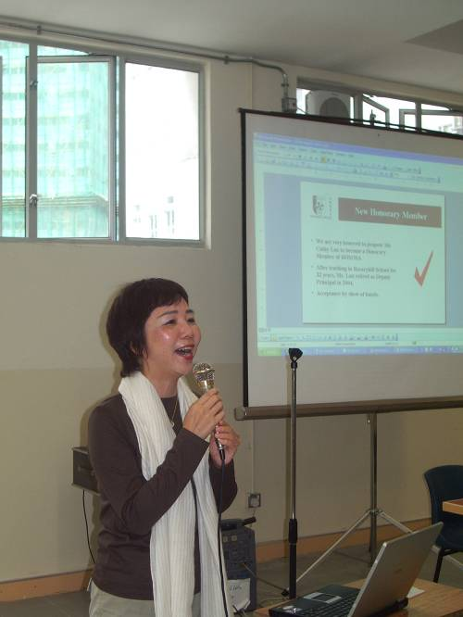
"The greatest reward is many of my students have now become my friends"

Ms. Cathy Lau accepts our invitation to become a RHSOSA Honorary Member in the 2006 AGM.

Love in a Fallen City (新傾城之戀)

Page 4 of 4
RHSOSA Newsletter #4

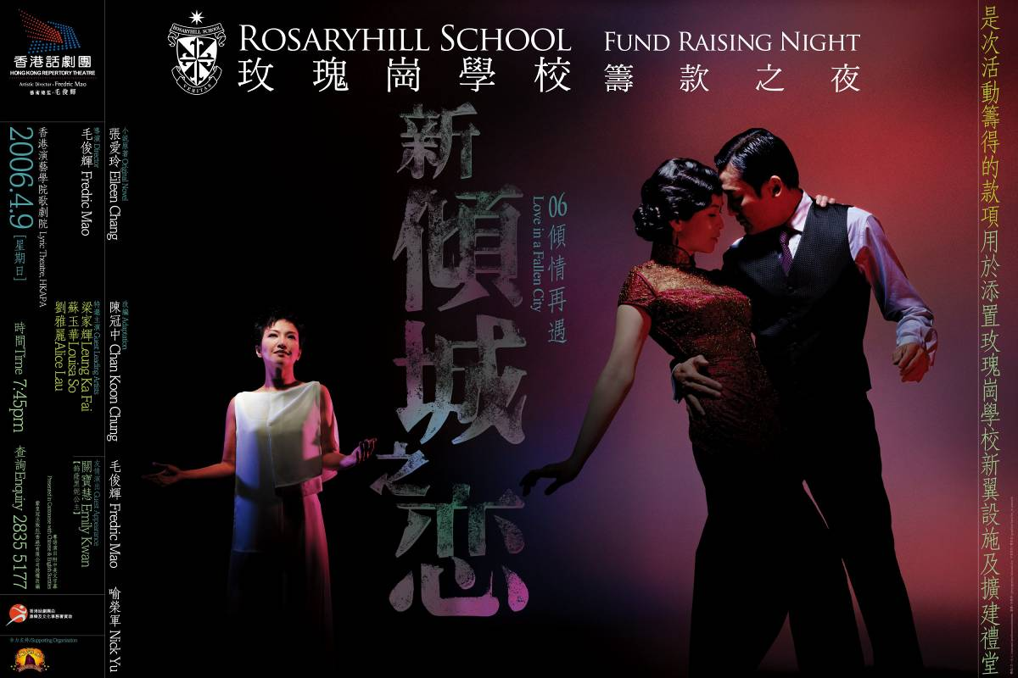
As part of the 2005 Rosaryhill School Fund Raising programme, one of the performance of the Hong Kong Repertory Theatre’s drama production of “Love in a Fallen City” has been reserved exclusively for the purpose of the Rosaryhill School’s fund raising and will be held on 9 April 2006 at the Lyric Theatre of the Hong Kong Academy for Performing Arts (HKAPA).

We are delighted to say that two of the leading cast members, Mr. Leung Ka-fai Tony and Ms. Alice Lau, are past students of our school. Mr. Edward Lam, one of the script writers of the 2nd edition, is also our past student. Mr. Chan Kin Bun, the Executive Director of the Hong Kong Repertory Theatre, is RHS’s ex-staff. It is a very meaningful night to meet all the old faces at the HK APA. Please contact Ms. Asli Chan by phone on 2835 5177 for ticket ordering or browse on the school homepage ( http://www.rhs.edu.hk. )

二零零六年四月九日（星期日）晚上七時四十五分香港話劇團將假香港演藝學院歌劇院上演「新傾城之戀」，此為玫瑰崗學校籌款活動的重點節目。

劇中兩位主角梁家輝先生、劉雅麗小姐及該劇的第二稿編劇林奕華先生均為我校校友，加上話劇團行政總監陳建彬先生曾為我校老師，無疑令該晚的演出別具意義。倘有任何查詢，歡迎致電2835 5177與陳小姐聯絡訂票或瀏覽本校網頁( http://www.rhs.edu.hk. ).

We’re on the Web!
See us at:
www.rhsosa.org

RHSOSA Newsletter Issue #4
Rosaryhill School Old Students Association

41B Stubbs Road, Wanchai, Hong Kong.

Email:
editorial@rhsosa.org

Rosaryhill School Old Students Association
41B Stubbs Road, Wanchai, Hong Kong.
http://rhsosa.org

Editorial Board:
Edward Ng
Patrick Rozario
David Chow

