Rosaryhill School

Old Students Association

RHSOSA Newsletter

Issue 11, December 2007

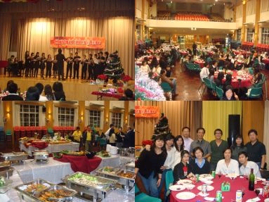


This issue:
- X'mas @ Home 2007
- Rosaryhill School Golden Jubilee (Page 2 to 3)
- News and Events (Page 4)
聖誕自助晚餐餐單 – X'mas Dinner Menu

什果沙律 / 什菜沙律
吞拿魚沙律 / 華都夫雞沙律
羅宋湯 / 碗仔翅
燒牛肉 / 燒豬脾
什凍肉 / 日式冷盤
煙三文魚 / 煙鮫魚
三文魚刺身 / 八爪魚刺身
聖誕火雞 / 燒羊脾
吉列龍脷柳配他他汁
紅酒燴牛尾配白飯
咖喱羊配白飯
煙鴨胸 / 蜜汁义燒
生炒骨 / 瑞士雞中翼 / 蒜茸牛油雞中翼
清炒雙菰 / 北菇伴小棠菜
肉醬焗意粉 / 瑤柱蛋白炒飯
生果盤 / 雪糕 / 汽水 / 啤酒 / 茶
芝士蛋糕 / 意大利芝士蛋糕 / 蜜桃批
檸檬慕絲 / 叉燒餐飽 / 糯米糍
沙翁 / 奶黃煎堆
X'mas @ Home 2007

The X'mas Dinner @ Home was successfully held at the school hall with about 100 attendees on 15/12/2007.
That evening was a warm and joyful evening on which all of the attendees enjoyed very much. The event was well organised by the organising committee of the RHSOSA. It is worth to mention that our Rosarian Choir gave an outstanding performance for us and we were all very impressed and grateful as this was their first performance since its establishment not so long before the event.
Moreover, we all enjoyed and were very impressed by the high quality of the scrumptious buffet dnner kindly provided by our school's canteen.

Page 2 of 4
Issue 11, December 2007

Rosaryhill School Golden Jubilee – 1959 to 2009

A letter from Fr. Franciso de las Heras, Supervisor, Rosaryhill School:

ROSARYHILL SCHOOL  GOLDEN JUBILEE  14 December 2007  To: Past-students, parents and friends  Re.: Activities of the GOLDEN JUBILEE | 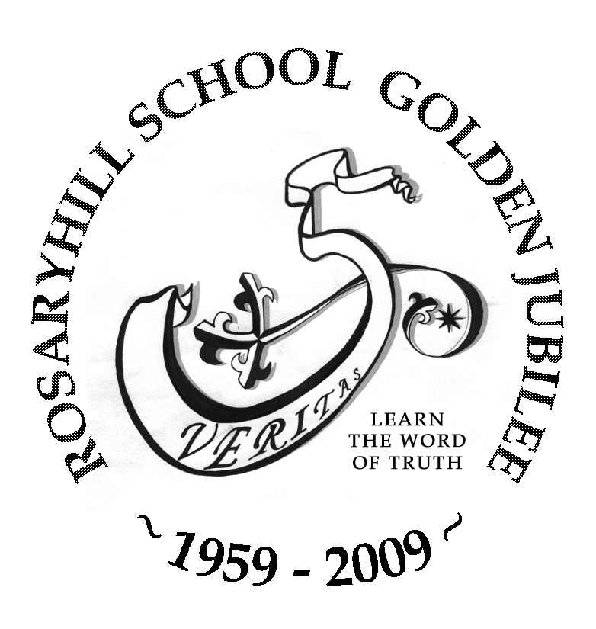

Dear past students, parents and friends of Rosaryhill School,

In August 2008 the Olympic Games will be held in Beijing, and a few weeks thereafter we will start with our 50th Anniversary Celebration. It is time that we inform all of you about the activities that we have planned for our Golden Jubilee celebration.

- Opening Ceremony, in the form of Solemn Mass in the Bernard Charnwut Chan Hall, in the morning of 6 October 2008 (the feast day of the school is the following day, Our Lady of the Rosary). We will invite our past students, parents and friends to join our staff and students to officially open our Golden Jubilee celebration and to pray to God, through the intercession of Our Lady of the Rosary, to continue bestowing on all of us His blessings.

- Gala Dinner, on 30 November 2008, at the Hong Kong Convention and Exhibition Centre. This celebration aims to gather our past students and friends, with the past and current Supervisors, Principals, teachers, staff, and parents. Our target is to gather more than 1000 persons for this dinner. The dinner also aims at raising funds to cover part of the expenses of the celebration and to start a scholarship that will be called the GOLDEN JUBILEE SCHOLARSHIP.

- School Open Days, on 6 and 7 December 2008. The official opening of the School Open Days will be held in the morning of 6 December. We have targeted the Open Days closed to the Gala Dinner so those students who may come from abroad can also enjoy this occasion of the Golden Jubilee celebrations.

- Music Gala, towards the end of March 2009, at a venue to be confirmed. At this Music Gala we will bring together the many talents of the past and the current students, parents and staff who will perform in a Musical that is being commissioned and written by persons related to our school. I can advance to you the title, Noah’s Ark, or “the vision of a mission”.

Page 3 of 4
Issue 11, December 2007

- Academic Activities, we will have four during the next school year, when we will invite past students to deliver talks on topics of interest for current and past students. We will let you have further details on these academic activities soon.

- Publications: we have already approached some of you about one of the publications, the History Booklet that we plan to publish. There will also be two DVDs presenting the school and the activities to be held during the Anniversary.

- Closing of Anniversary Celebrations, in the month of July 2009.

Our Golden Jubilee celebrations will only be successful with the participation of all Rosarians and friends of the school. Please start making plans for the next school year so that you can be part of this important celebration in the life of the school, significant especially for those who have been and are part of her.

May God and our Patroness, the Lady of the Rosary, bless us all,

Fr. Francisco de las Heras
Supervisor

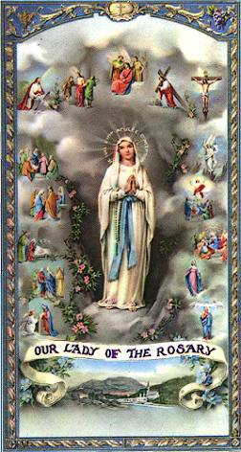

Page 4 of 4
Issue 11, December 2007

2008 Annual General Meeting cum Fun Fair Day

The Rosaryhill School Old Students Association (“RHSOSA”)’s next Annual General Meeting ("AGM") together with a Fun Fair Day will be held on 1st March, 2008.

At the AGM, you will have the opportunity to elect the RHSOSA’s next president and the executive committee; you can find the nomination form in www.rhsosa.org. Please return it to president@rhsosa.org on or before 23rd February 2008.

Moreover, the RHSOSA Executive Committee will propose some changes to our current constitution; you can also find the proposed amendment to the Constitution in www.rhsosa.org.

Apart from the Annual General Meeting, we have organized a Fun Fair Day. There will be various competitions for the members to take part; there will also be different games which are specially designed for the members who have children to participate. Details of the above event are as follows:

Date: 1st March 2008
Venue: Rosaryhill School’s campus
Programme: 1:30pm --2:30pm Game Booths
2:30pm --3:15pm AGM
3:15pm --4:00pm Refreshment
4:00pm-- 5:00pm Treasure Hunt & Competitions
5:00pm – 5:15pm Lucky Draw
Fees: Free of charge
Transportation: School bus will be available for going down to WanChai at 5:30pm.

As we will have to make arrangements for the competitions, transportation and refreshments in due course, we appreciate it if you would fill out the AGM registration form in www.rhsosa.org and send it back to us at activities@rhsosa.org on or before 23rdFebruary 2008.

Looking forward to seeing you all in the 2008 AGM cum Fun Fair Day.

RHSOSA Newsletter

Issue 11,

December 2007
Rosaryhill School
Old Students Association

41B Stubbs Road, Wanchai, Hong Kong.

Email:
editorial@rhsosa.org

Editorial Board:
Patrick Rozario
David Chow
Edward Ng

Honorary Advisor:
Ms. Cathy Lau
We’re on the Web!
See us at:
http://www.rhsosa.org

Rosaryhill School Old Students Association
41B Stubbs Road, Wanchai, Hong Kong.
http://www.rhsosa.org

