Rosaryhill School

Old Students Association

RHSOSA Newsletter

Issue 10, September 2007

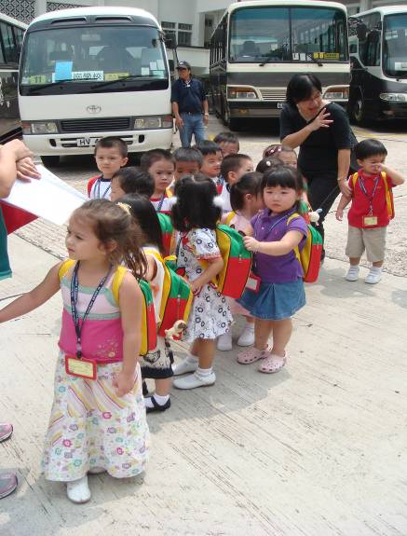
This issue:
- New School Year 2007 to 2008 (Page 1 to 2)
- RHSOSA Scholarship Award (Page 2 to 3)
- Rosaryhill School 50th Anniversary Celebration (Page 4)
- News and Events (Page 5)
The new school year started on 3 September 2007. Previous to the official opening we had the preparation days organized by each section. The Secondary and Business Studies Sections had their Orientation Days for their new students; the Primary Section and Kindergarten had their day to brief parents about the new schooling of their children. There was lots of information to provide during those days, and parents had many questions that showed their anxiety on the new schooling of their young children.

3 September was the official school opening day although only Secondary and Business Studies Sections started the school on the first day. It was just a short day, students left school before lunch. The Secondary Section had the Opening in a formal way, with a function in the School Hall where we invited successful past students to act as guests of honour and to talk to the students in this first day. The students we invited this year were Dr. Vember Ng for the senior students and Ms. Lydia Lau for the junior ones: both shared their memories with their younger brothers and sisters, and the students’ attention during the speeches was outstanding. The Business Studies students had their opening in a more causal way; they had the chance of meeting all their subject teachers who spent a few minutes of the morning with their respective classes.

4 September was the first school day for Primary Section, who also had a short day, just a few hours of the morning, to have their first contact with the school, with the teachers, with their classmates after the long holiday.

New School Year 2007 to 2008

Kindergarten students started by stages also on 4 September and they came just for a short while: the task of the Kindergarten teachers to make some students adapted to the school is really hard, it takes in some cases weeks until some little kids stop crying for mammy. The first week becomes also days of adaptation for the other students of Kindergarten.

Also part of the school opening is the mass or prayer that we have with the different groups during the first week, entrusting to God all the many good efforts and work of our teachers and students.

Let us say that Kindergarten and all the sections of the school has started the school year smoothly even if this year we face a major change in the school hours of the different sections.

By Ms. Kitty Ho

School Year 2007
To 2008
Page 2 of 5
Issue 10, September 2007

New School Year 2007 to 2008

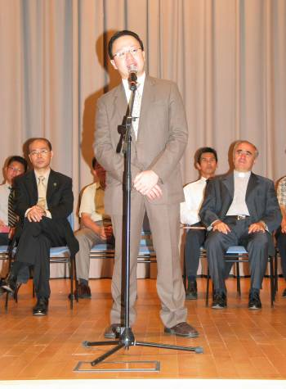
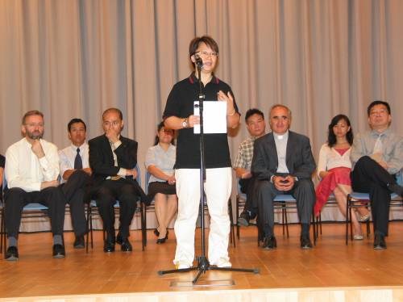

RHSOSA Scholarship Awards
Ms. Lydia Lau

In June 2005, we launched the RHSOSA Scholarship Awards Programme for both Secondary Section and Kindergarten Section. From 2006, the same award was also being offered to the Primary Section.
The objectives of the RHSOSA Scholarship Awards are
- to recognize students with outstanding achievement in their studies, in particular Chinese Language and English Language, and
- to promote and cultivate the learning of Chinese Language and English Language.

Details of the rules and regulations are available on the OSA web site. We are very delighted to announce the following 2007 award winners.

Dr. Vember Ng

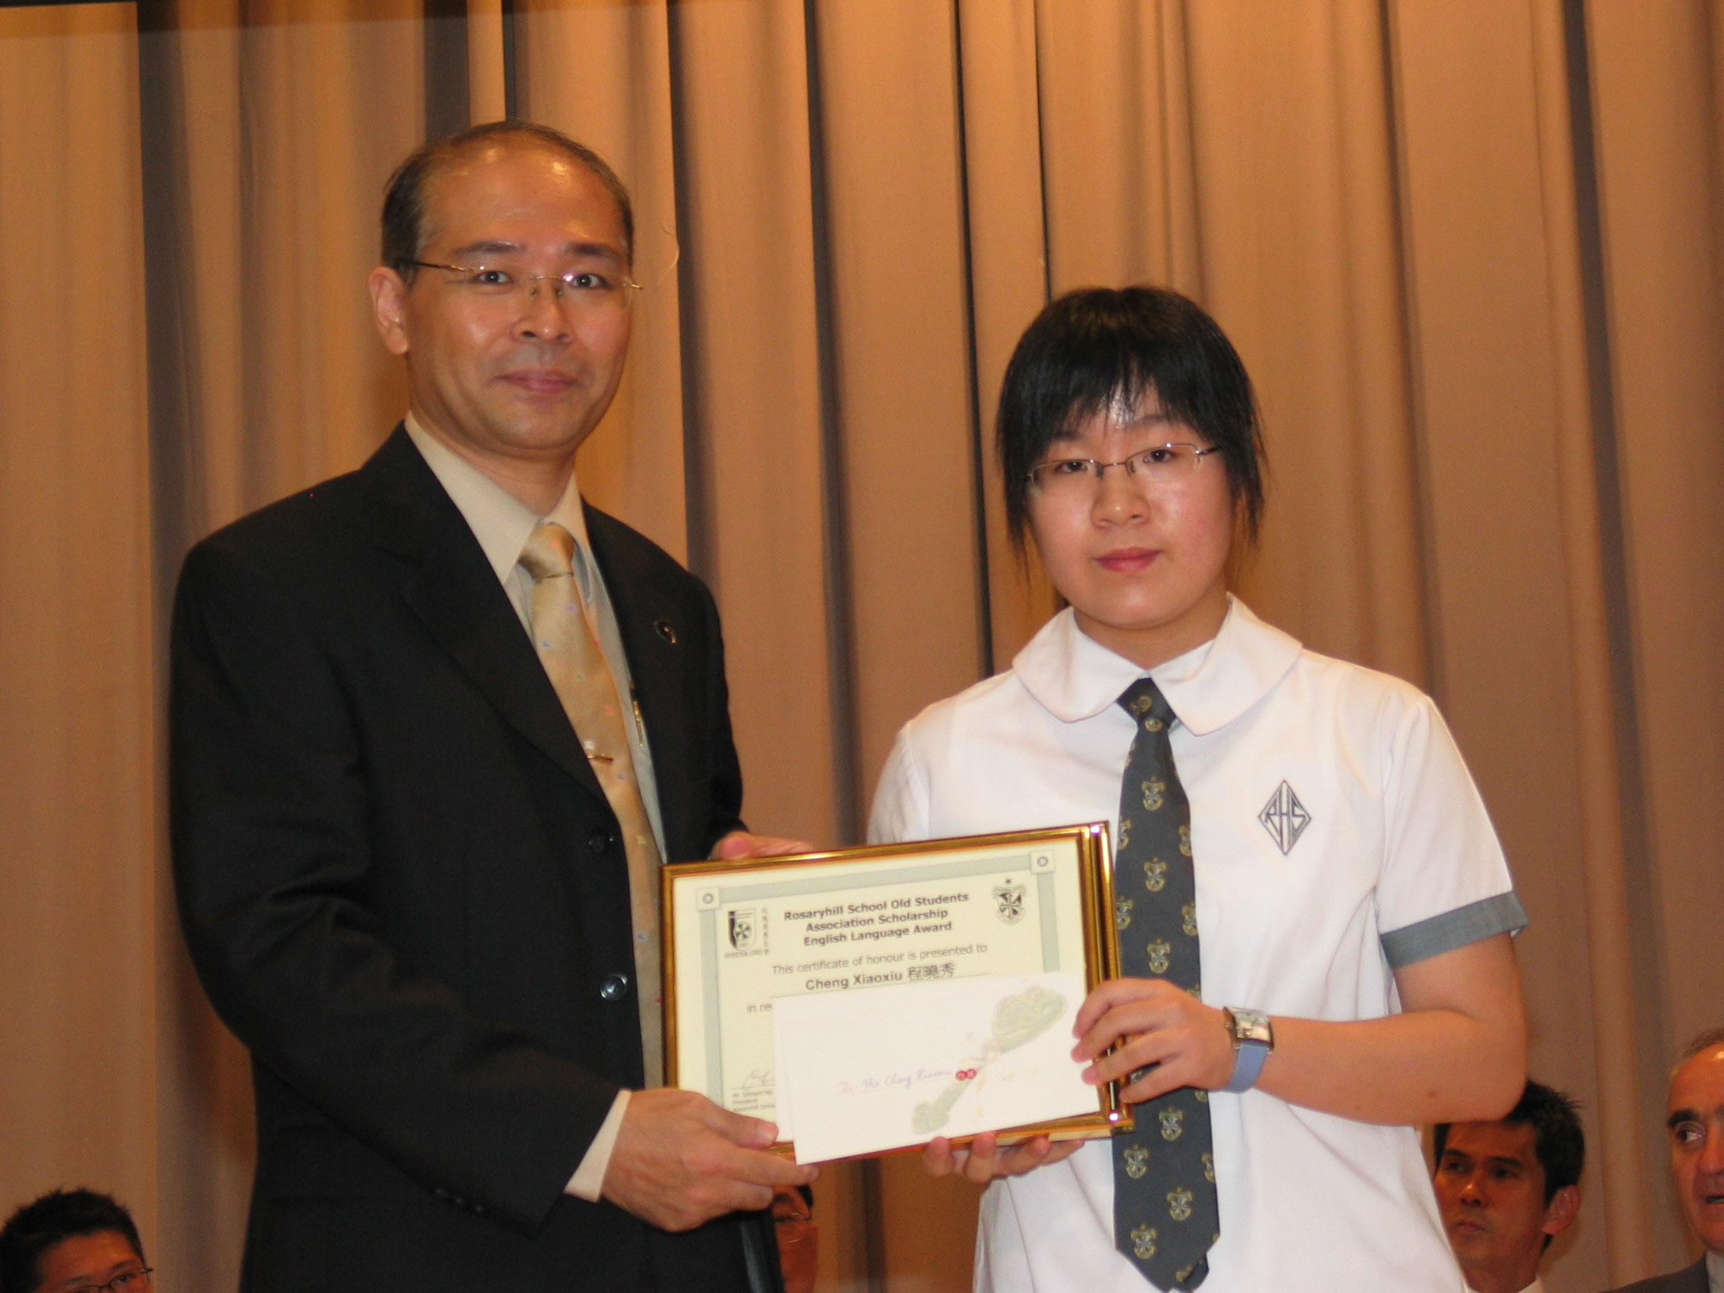
Page 3 of 5
Issue 10, September 2007

RHSOSA Scholarship Awards

Some of the award winners

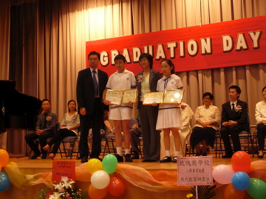

Primary School Award Winners

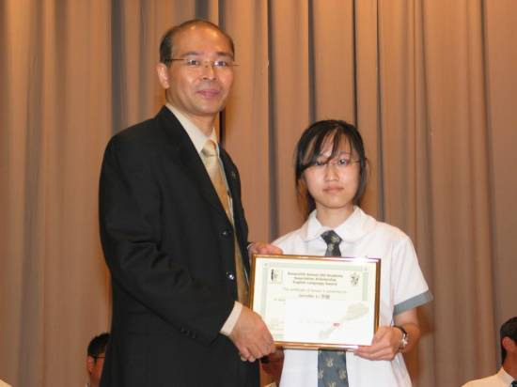
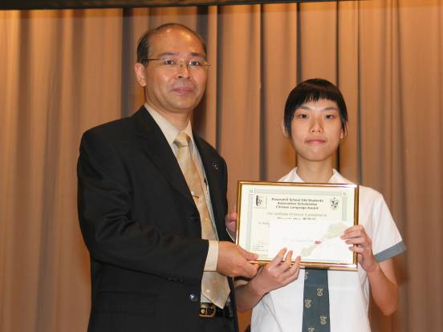

Ms. Jennifer Li

Ms. Xiao Xiu Cheng
Ms. Miranda Mak


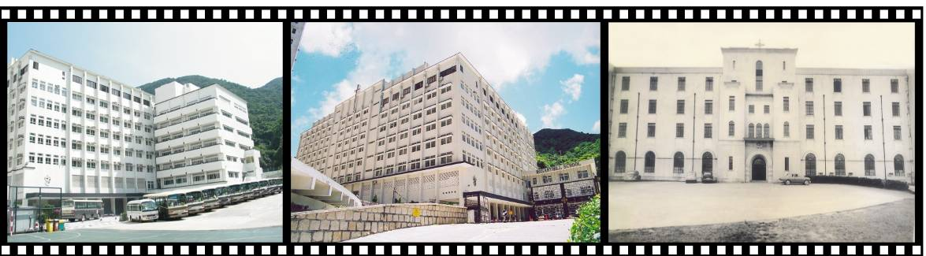

Rosaryhill School 50th Anniversary Celebration

Page 4 of 5
Issue 10, September 2007

Look out for the new update in the next issue of RHSOSA newsletter, the school year 2008 to 2009 marks the 50th Anniversary of the foundation of our school and it will be a year for all of us to celebrate the half century of history of our school.

We will maintain a column in the newsletter to keep you inform of the activities that the School and RHSOSA will organise for the celebration towards and over the 50th Anniversary Celebration.

Fr. Francisco de las Heras has distributed a letter to all parents, past and present students of Rosaryhill School in April 2007. The letter conveyed that the Motto chosen for the celebration is LEARN THE WORD OF TRUTH, which symbolise the three main identities of our school: in education, religion and history. The Motto is very much based on the spirit of the Dominican Order that emphasises on strong religious commitment in the work of education and in truth. The insignia of the Dominican Order, also adopted as our School badge has the Latin's inscription "VERITAS" meaning TRUTH.

The main objectives that the School has decided for the anniversary celebration are:
- To celebrate the 50 years of existence of our School (Historical identity).
- To ponder on our past as a Catholic institution and to strengthen our future (Religious identity).
- To foster a sense of pride in the past, present and future generations of Rosarians of being members of our school (Educational identity).
- To assist administrative staff and teachers to achieve greater fulfilment as members of a Catholic educational institution (Religious and education identities).

The first event which has already been started is the 50th Anniversary Celebration Logo Design Competition. For detail of the logo design competition, please see www.rhsosa.org or contact the School directly. A copy of Fr. Francisco de las Heras's letter can also be found on the RHSOSA website.

The 50 the Anniversary Celebration is entrusted to our Lady of the Rosary, Patroness of our School.

RHS Walkathon 2007
The hiking season has started! After our last trip to Macau, the RHSOSA’s next upcoming event is the “Walkathon 2007 which is scheduled to be held on 2nd December 2007. It is the school’s fundraising event which takes place once every 2 years. On the day you will get to enjoy the beautiful countryside of the Hong Kong Island together with your former teachers, your friends and the current students. Details of the activity are as follows:
\
Date: 2nd December 2007
Time: 8:30am to 10:30am
Route: From Wong Nei Chung Gap Road near Hong Kong Parkview (陽明山莊) to Quarry Bay.

If you are interested to join us, please fill out the enclosed donation form and return to us at activities@rhsosa.org on or before 24th November 2007.

RHSOSA Newsletter

Issue 10,

September 2007
Rosaryhill School
Old Students Association

41B Stubbs Road, Wanchai, Hong Kong.

Email:
editorial@rhsosa.org

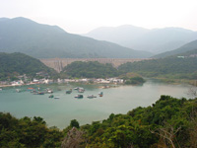
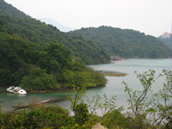

Editorial Board:
Patrick Rozario
David Chow
Edward Ng

Honorary Advisor:
Ms. Cathy Lau

We’re on the Web!
See us at:
http://www.rhsosa.org

Rosaryhill School Old Students Association
41B Stubbs Road, Wanchai, Hong Kong.
http://www.rhsosa.org

X'mas Dinner @ Home
You are cordially invited to join the RHSOSA’s final event in 2007 at school hall on 15 December 2007.

More details about the event will be posted on our website in due course. Please browse www.rhsosa.org from time to time to keep yourselves informed!

2008 AGM + Family Games Day
Wouldn’t it be nice to show your children the place where you spent your childhood? We plan to organize a family games day for our alumni to spend a day at your alma mater together with your family. It will be held together with the 2008 AGM. We hope the 2008 AGM can bring more fun to all of you. If you would like to offer any assistance, please send an e-mail to us at webmaster@rhsosa.org.

Lookout for the 2007 / 2008 Events and Activities

