Rosaryhill School

Old Students Association

RHSOSA Newsletter

Volume 3, 2006



This Volume:
- Mid-Autumn Festival
- 2006 Farewell Dinner and Mah-jong Competition
- RHSOSA Scholarship Awards
- A message from our President – RHSOSA Registration
- Hiking and Seafood lunch in Lamma Island
(人月兩團圓) “When the moon is full, mankind is one". The full moon has always represents the gathering of family and friends. The Mid-Autumn Festival is a time for reunion.

The Rosaryhill School Old Student Association wishes you and your family a happy Mid-Autumn Festival. When you celebrate the festival, enjoy the getting together with your family and friends while appreciating the delicious moon cakes and pomeloes; and the most beautiful moon !
The Mid - Autumn Festival

花好月圓人團圓

齊聚團圓慶中秋

中秋

Volume 3, 2006
Page 2 of 4

2006 Farewell Dinner and Mahjong Competition

On 29 July 2006, we held an OSA dinner gathering at Shun Tak Centre’s Foo Lum Fisherman’s Wharf Restaurant. About 60 guests and alumni joined the function. Participants included graduates from 1973 to 1999, and two of them were our primary graduates, too.

We had the pleasure to invite two teachers as our guests - Ms. So Choi Yin and Mr. Thomas Pak. Both of them have now retired from the school, and we took this opportunity to express our thanks for their teaching.

In addition, we also celebrated the retirement of Fr. Francisco from the post of secondary section’s principal. He was the secondary section’s principal for the past 13 years. Anyway he will continue to serve the school in the capacity of the supervisor of the secondary, primary and kindergarten sections and the principal of the primary section.

On that night, everyone enjoyed the gathering with lots of sharing of memories, funs, food and gifts. Lastly, Margaret Tsai from the class of 1973 won the title of 2006 Queen-of-mah-jong with a cash prize of $1,000. If you would like to challenge to her title, please remember to register for the 2007 mah-jong competition.

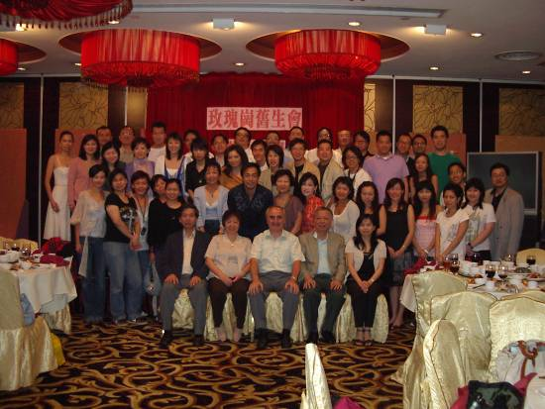

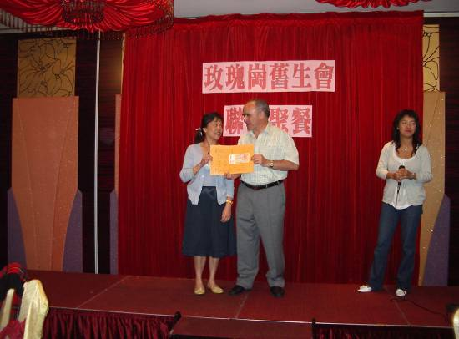
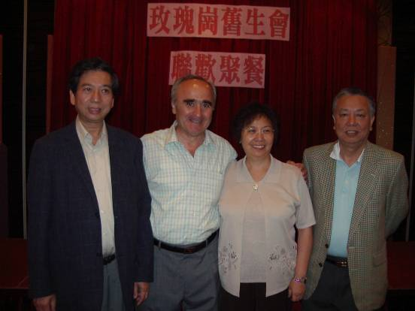

Margaret collecting the $1,000 cash prize from Fr. Francisco.

(from left) Mr. Chan Kin Bun (husband of Ms. So), Fr. Francisco de las Heras, Ms. So Choi Yin and Mr. Thomas Pak.

The Group Photo

Page 3 of 4
Volume 3, 2006

RHSOSA Scholarship Awards

In June 2005, we launched the RHSOSA Scholarship Awards Programme for both Secondary Section and Kindergarten Section. From 2006, the same award will also be offered to the Primary Section.
The objectives of the RHSOSA Scholarship Awards are
- to recognize students with outstanding achievement in their studies, in particular Chinese Language and English Language, and
- to promote and cultivate the learning of Chinese Language and English Language.

Details of the rules and regulations are available on the OSA web site. The following table lists out the 2005 award winner. In the next issue, we shall announce the 2006 award winners.

Section | Award | Name of Award Winner | Class
Kindergarten  Secondary | Academic Achievement Award  Chinese Language Award  English Language Award | Chow Angel 周映佐  Chan Yu Hin, Matthew 陳裕軒  Lee Chun Yu 李俊瑜  Leung Hoi Nga 梁凱雅  Luk Hoi Ki 陸凱琪  Mak Hau Ling, Angel 麥巧玲 | UC  UD  S. 5C  S. 5A  S. 5C  S. 5A

Dear Rosarians

The Rosaryhill School Old Students Association (“RHSOSA”) is currently updating the database of our members. We sincerely hope that you would spare a few minutes and register with us on our website (www.rhsosa.org) again so that we could build a more complete database of our alumni. With your help, we will be able to keep you informed of the latest news and activities of the school and RHSOSA via emails and the information posted on our website in the future.

Moreover, we also hope that you could encourage your fellow Rosarian friends to register with us too and our RHSOSA family will grow bigger and bigger.
Thank you very much,
Edward Ng, President
RHSOSA

A message from our President – RHSOSA Registration

Hiking and Seafood Lunch in Lamma Island

Page 4of 4
Volume 3, 2006

After the long hot summer, it is the hiking season again. RHSOSA is organising a hiking and seafood lunch in Lamma Island. We will hike from Yung Shue Wan (榕樹灣) to Sok Kwu Wan ( 索罟灣), then we will have seafood and visit the Fisherfolk's village.
Details of the event are as follows:
Date: 5th November 2006
Fee: Audit @ $ 188;
Child @ $138
(The fee covers seafood lunch, entrance fees to the Fisherfolk's Village & transportation from Sok Kwu Wan back to Central).

Activity Rundown:
09:15 Assembly at Central Pier No. 4
11:00 Hiking from Yung Shue Wan to Sok Kwu Wan
13:00 Seafood lunch at Rainbow Seafood Restaurant
14:30 Visit the Fisherfolk's Village
16:55 Free ferry leaving Lamma Island
To enrol, please make exact payment into the RHSOSA HSBC a/c no. 002-0-191581 and fax the bank-in slip to 2810-0777 (Attn: Edward Ng) or email to activities@rhsosa.org with your personal information including a). no. of participants & name (adult / child) and b). your contact phone number before 27th October 2006.
We look forward to seeing you soon!

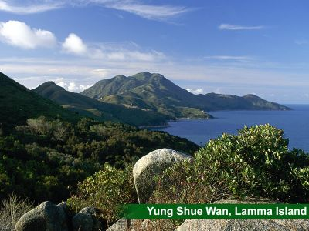

RHSOSA Newsletter Volume 3, 2006

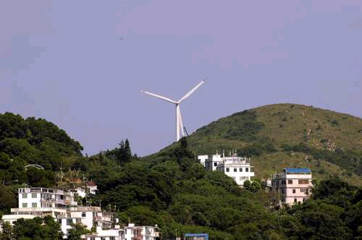
We’re on the Web!
See us at:
www.rhsosa.org
ROSARYHILL SCHOOL OLD STUDENTS ASSOCIATION

41B Stubbs Road,
Wanchai, Hong Kong.

EMAIL:
editorial@rhsosa.org

Rosaryhill School Old Students Association
41B Stubbs Road, Wanchai, Hong Kong.
http://rhsosa.org

Editorial Board:
Edward Ng
Patrick Rozario
David Chow
Monica Cheung Mok

