Rosaryhill School

Old Students Association




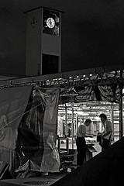
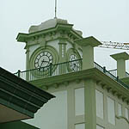
"Watching the ferry sail by
Seeing the pier tumble
As the scene around us changes.
Time goes by."

RHSOSA Newsletter

Volume 4, 2006
This Volume:
- Happy New Year!
- Hiking and Seafood Lunch in Lamma Island
- 2006 RHSOSA Scholarship Awards
- RHS Prize Giving Day
- RHSOSA Annual General Meeting and Pun Choi
Christmas had come and gone. As soon as the new star ferry clock tower struck 12'o'clock, gone are the 364 days of 2006 and here comes the New Year 2007.

The RHSOSA hopes you have a wonderful and successful 2006. May 2007 bring you and your family happiness, good health and good fortune.

RHSOSA will continue to provide a channel for all RHS old students to stay in touch with our alma mater and our old friends so that the Rosarian family will become bigger and stronger.

Happy New Year!

Volume 4, 2006
Page 2 of 5

Hiking and Seafood Lunch in Lamma Island

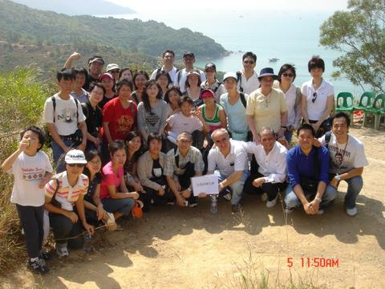
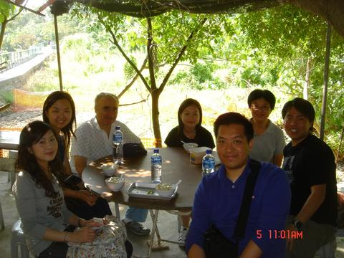

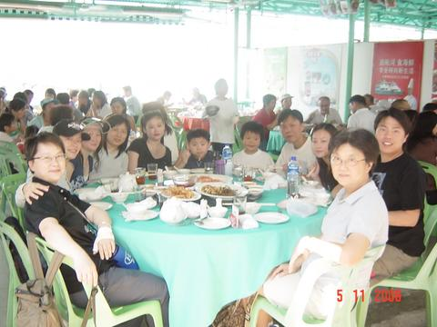
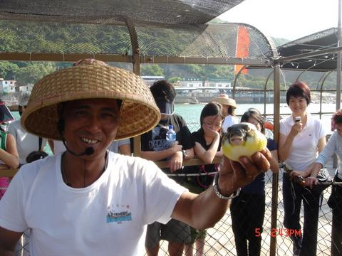

Prawns, fish ….etc. in the Rainbow Restaurant.

Around 45 of us including Fr. Francisco, Ms. Betty Suen, Ms. Cathy Lau, Ms So Choi Yin, many Rosarians and their family members joined the RHSOSA's 2006 hiking on 5 November 2006.

We selected a beginners’ trail which started from Yung Shue Wan to Sok Kwu Wan on Lamma Island and our walk was started at around 10:45am. During the 100 minutes walk, we enjoyed the sunny weather, the green environment as well as the famous and tasty bean curd.

After hiking, we enjoyed a delicious seafood lunch in the Rainbow Seafood Restaurant. Then, a very interesting visit to the Fisherfolk’s Village had made our activity even more educational. We learnt from the local fishermen that their daily works and lives on the fishing boat. We also got the chance to see different kinds of fish such as shark and puffer fish (雞泡魚), etc. We tried to “fish without hook” there and some of us had even brought their capture back home. All of us have enjoyed very a wonderful and meaningful trip.

Have you ever seen a puffer fish (雞泡魚)?

Enjoying famous bean curd
Such a beautiful sunny day... The Group Photo

Page 3 of 5
Volume 4, 2006

2006 RHSOSA Scholarship Awards
We have given out the 2006 RHSOSA Scholarship Awards. Each Kindergarten and Primary School winner received a HK$ 1,000 prize and each Secondary School winner received a HK$ 1,500 prize. The following are the 2006 award winners:

Kindergarten Section
On 24 June 2006 Mr. Edward Ng, our President, presented the 2006 RHSOSA Academic Achievement Awards to the three winners from our Kindergarten Section. The winners were:
LONG Matthew 龍慕軒 (UA)
NG Siu Hin, Jayden 吳肇軒 (UB)
LOO Yat Him, Thomas 盧溢傔 (UW)

Primary Section
In this year, the RHSOSA Scholarship Award is further extended to benefit the Primary Section. Similar to the Secondary Section, there are two winners for Chinese Language Award and two winners for English Language Award. On 8 July 2006, our President presented the awards to the primary students.

The winners of the 2006 Chinese Language Award were:
TSE Yi Chun 謝爾駿 (P6A)
CHEUNG Tsz Long, Matthew 張子朗 (P6B)

The winners of the 2006 English Language Award were:
GEOPANO Gus Melzar Casela (P6A)
WONG Hog Yin 黃學言 (P6A)

Secondary Section
On 25 November 2006 our President presented the 2006 RHSOSA Scholarship Awards to the winners from the Secondary Section.

The winners of 2006 Chinese Language Award were:
Lau Wai Keung劉煒強 (S.5F)
Tse Hong Wing謝漢榮 (S.5A)

The winners of 2006 English Language Award were:
YANEZA Gretchell 楊麗珊 (S.5D)
LUI Sze Ming 呂思明 (S.5A)

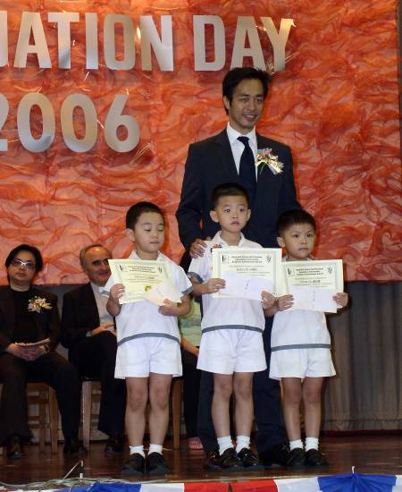

The Kindergarten Winners

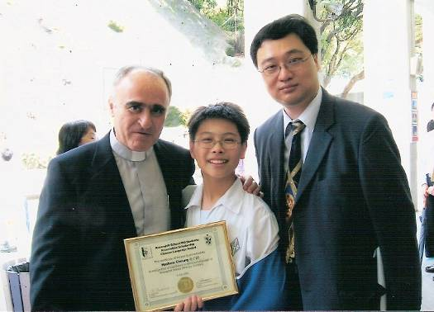

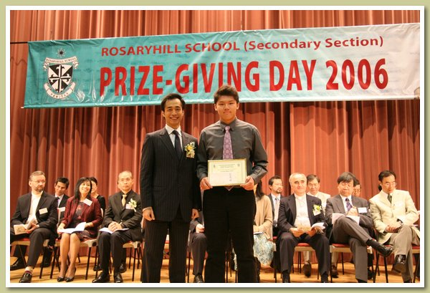
CHEUNG Tsz Long, Matthew 張子朗 (P6B)
LUI Sze Ming 呂思明 (S.5A)

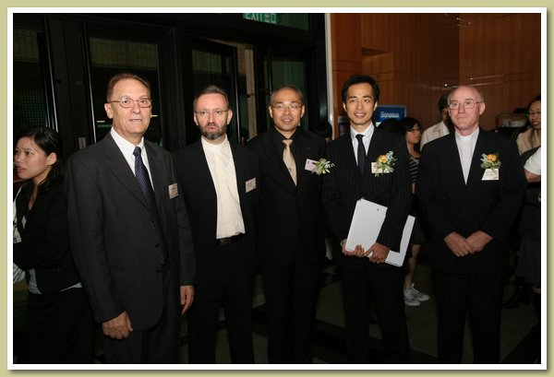
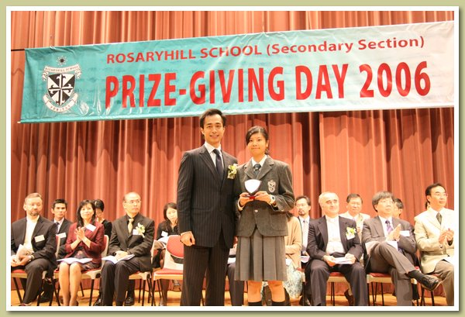
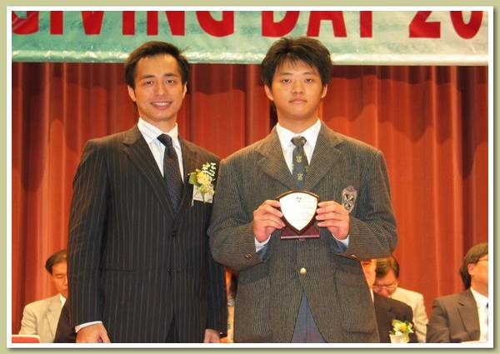

On 25 November 2006, one of the most significant events in Rosaryhill School, the Annual Prize-giving Day, was successfully held at Leighton Hill Community Hall. This year we had the pleasure of having Fr. Bonifacio Garcia Solis, O.P., Prior Provincial of the Province of Our Lady of the Rosary to be our Guest of Honour. Together with the Fathers, Mrs. Peggy Lam, the Chairperson of the Parent-Teacher Association and, Mr. Edward Ng, the President of RHSOSA, joined the ceremonial party and presented prizes to the prize-winners. In the ceremony, a total of 146 prizes were presented to the prize-winners. Over 100 teachers and 120 guests including parents, alumni and friends of Rosaryhill School joined us in sharing the joy of the students.

After the presentation of prizes was a series of performances. This year various parties who had won outstanding awards in the open competitions presented their winning performances. Their marvellous performances won the applause of every member of the audience in the hall. Photos from the event show the joy that was held by all.

Congratulations to all of the prize-winners and thanks for the support of all the guests once again.

RHS Prize Giving Day 2006
Page 4 of 5
Volume 4, 2006

RHSOSA Annual General Meeting and Pun Choi

Page 5of 5
Volume 4, 2006

Time flies. Another year had gone by quickly, it is time again to organise our Annual General Meeting (AGM). The AGM of RHSOSA will be held on 3 March 2007 at 2 p.m. in the newly renovated RHS school hall (Bernard Charnwut Chan Hall). The notice of the AGM and the nomination form of the executive committee (2007 – 2008) will be sent out to all members shortly.

In 2006, RHSOSA has organised a number of activities and participated in many school events including:
- Love in a Fallen City (新傾城之戀)
- 2006 Farewell Dinner and Mahjong competition
- Hiking and Seafood Lunch in Lamma Island
- 2006 RHSOSA Scholarship Awards
- RHS Prize Giving Day

RHSOSA hopes to continue to do its best to foster a closer tie of our alumni with the larger RHS community of students, teachers, staff and parents.

In addition to the AGM, RHSOSA will organise a Pun Choi meal to celebrate the new Gold Pig Year during the AGM, The RHSOSA Executive Committee are looking forward to seeing you in the AGM.

To enrol, please make exact payment into the RHSOSA HSBC a/c no. 002-0-191581 and fax the bank-in slip to 2810-0777 (Attn: Edward Ng) or email to activities@rhsosa.org with your personal information including a). no. of participants & name (adult / child) and b). your contact phone number before 27th October 2006.
We look forward to seeing you soon!

RHSOSA Newsletter Volume 4, 2006

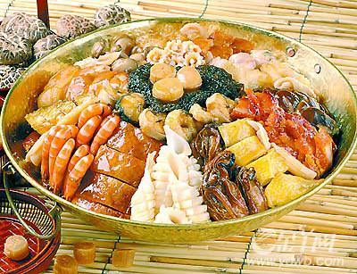
We’re on the Web!
See us at:
www.rhsosa.org
ROSARYHILL SCHOOL OLD STUDENTS ASSOCIATION

41B Stubbs Road,
Wanchai, Hong Kong.

EMAIL:
editorial@rhsosa.org

Rosaryhill School Old Students Association
41B Stubbs Road, Wanchai, Hong Kong.
http://rhsosa.org

Editorial Board:
Edward Ng
Patrick Rozario
David Chow
Monica Cheung Mok

