Rosaryhill School

Old Students Association

RHSOSA Newsletter

Volume III / IV, 2008

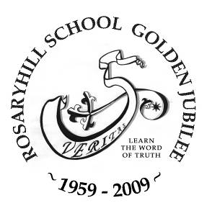
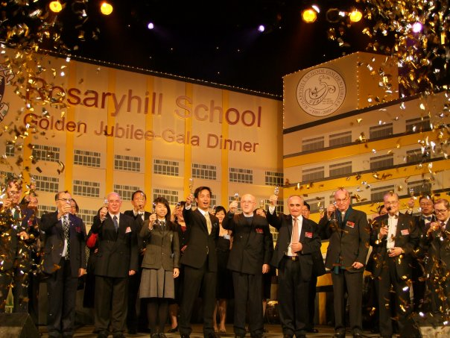
This issue:
- Rosaryhill School's Golden Jubilee Gala Dinner (Page 1 to 2)
- Golden Jubilee Book (Page 3)
- 2008 Open Day (Page 4 )
- Annual General Meeting cum Dessert Appreciation & Ball Games Competition (Page 5)
- News and Events (Page 6)
Rosaryhill School's Golden Jubilee Gala Dinner

The Rosaryhill School's Golden Jubilee Gala Dinner was successfully held on 30th November 2008 at the Convention Hall in the Hong Kong Convention and Exhibition Centre. It was in fact the biggest dinner celebration ever organised for the celebration of RHS' anniversaries. A total of 81 tables were booked in that evening, participants of the night included various fathers, teachers, past students, students, staff and school bus drivers.
The night was not only meaningful for the Alma Mater to celebrate her 50th anniversary but it had a special meaning for those who had left RHS for quite some time; so it was a great opportunity for the dinner participants to catch up with their old school friends, teachers and school staff as well. We also saw a great number of long lost faces at the Gala Dinner and some of them even flew all the way from overseas to attend the Dinner.
Apart from being a celebration dinner for the school's 50th anniversary, it was also a fundraising dinner for the newly established Rosaryhill School Golden Jubilee Scholarship Fund. More than HK$2,000,000 was raised from the event and the fund will be used for the benefit of the RHS's students in the future.
The programme of the night included video show of RHS' past 50 years development, group photo taking of various years on stage, changing mask performance by Wai Choi Hung, a former student, singing performance delivered by the OSA choir The Rosarian Singers...etc. Most dinner participants were greatly impressed by the programme as well as the impressive stage backdrop in the dining hall, which imitated the school campus of RHS. A series of 50th Anniversary souvenirs were launched and they were very popular items for our guests and dinner participants. The Gala Dinner ended at around 11pm finally and everyone left with a joyful memory.

More Gala Dinner's Photos in the next Page

Page 2of 6
Volume III/IV, 2008

Rosaryhill School's Golden Jubilee Gala Dinner

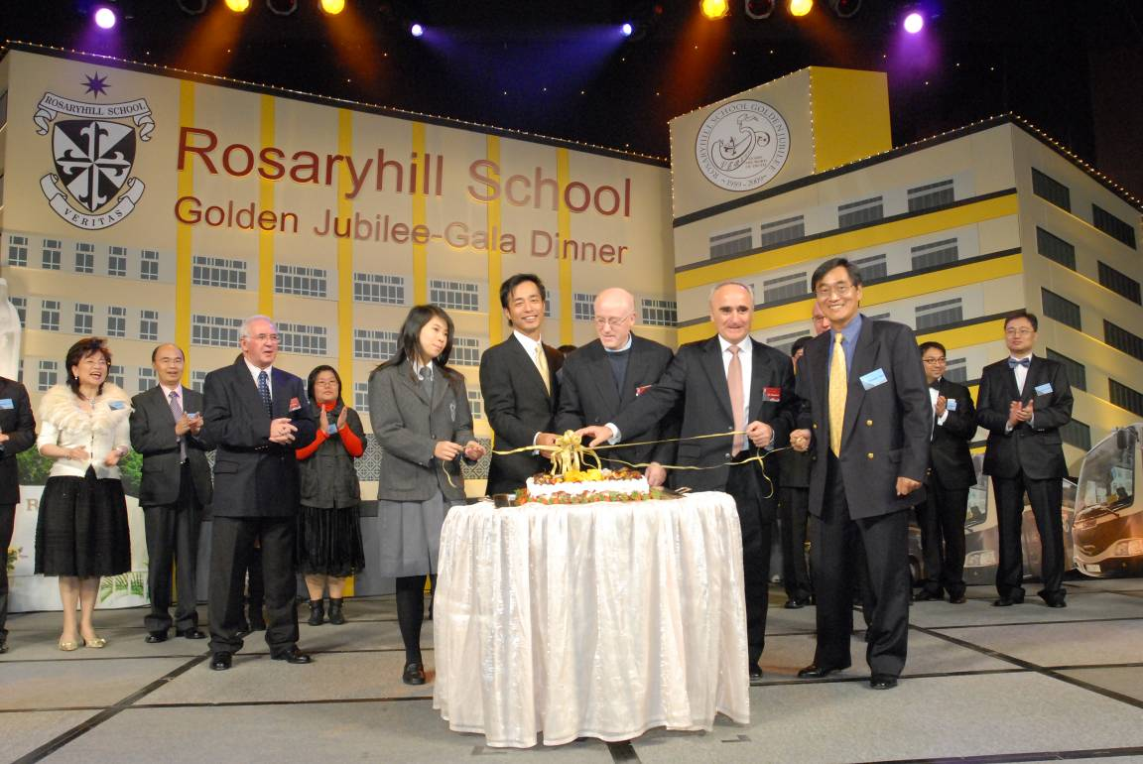

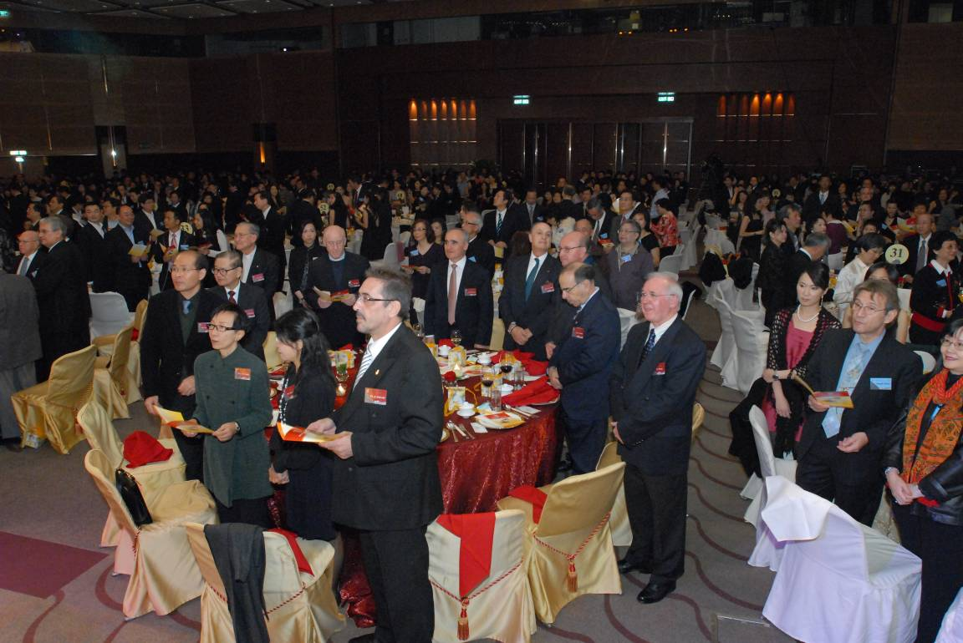
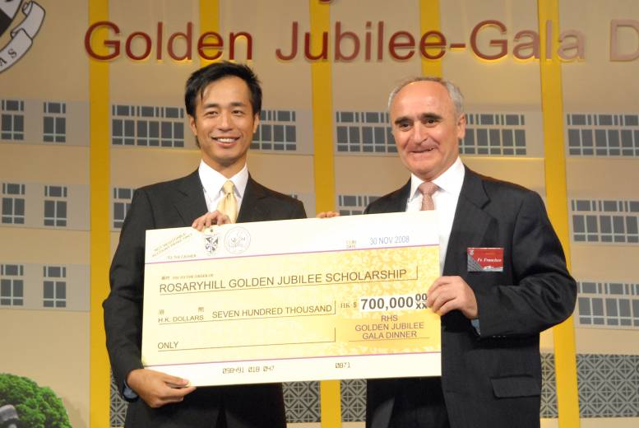
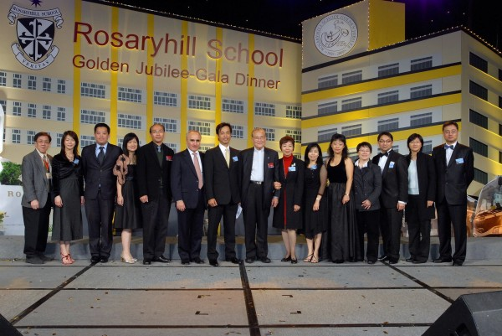

”Cake Cutting Ceremony.”
”Cheque presentation for the Golden Jubilee Scholarship”
”Singing our School Song.”
”RHSOSA 2008 to 2009 Executive Committee.”

Page 3 of 6
Volume III/IV, 2008

Golden Jubilee Book (Rosaryhill School 1959 to 2009)

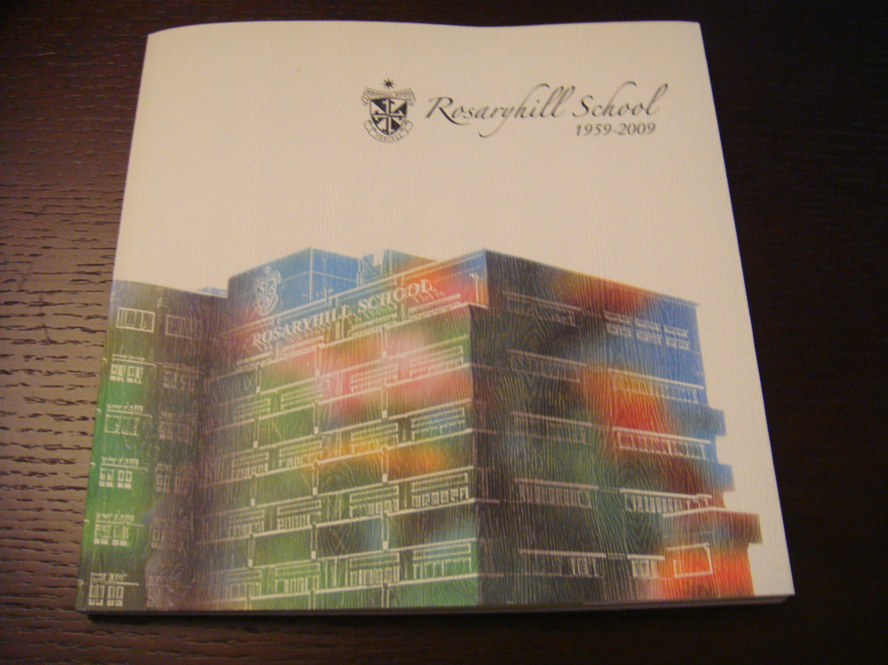

Almost every fifth Anniversary of the school we produce some sort of publication to commemorate the event. These publications try to reflect upon different aspects of our school’s history and important events that have taken place. In the one published 10 years ago major emphasis was placed on those teachers in the school who had been nurtured as students in our school.

When we met to design the book of the Golden Jubilee we were in a dilemma: we wanted a book that would not be a replica of those written before. We know that history cannot be changed, although there are events that could be seen differently over time. We thought to base our book on the persons who have made that history, like the administration –Supervisors, Principals, Deputy Principals, Heads of Departments, past and actual teachers who have been in the school for years and past and actual students.

Our Editor, Ms. Bonnie So, came up with a beautiful idea to express in a better way the direction or “theme” of the book. She suggested the idea of Rosaryhill as a Garden, or the “Hill of Roses”, where there are custodians of the garden, gardeners and a variety of beautiful roses or flowers. In time our book began to develop into a reality. Many different people were contacted to obtain their feelings, their memories about the years spent in the school. We subsequently published the book that has now been widely read, well received and widely accepted.

In the book we have included past and recent photos. We have also included a brief history, because we thought it important to pay tribute to the 50 years of our school. We explain some aspects that make our school different, as it is the “Fathers’ Council” that has been the main governing body in the school. But above all, we have the testimonies of many persons who have been or still are part of the school!

The book is available for sale at the school. The cost is just $100 (plus postage if requested by mail). You may obtain it from the school stationery, or through the office. We will also try to make it available to all during future, major events in the school.

Many past students have expressed their happiness after obtaining it.

Fr. Francisco de las Heras
Supervisor

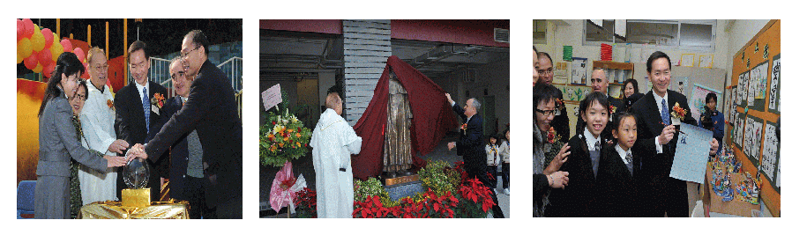
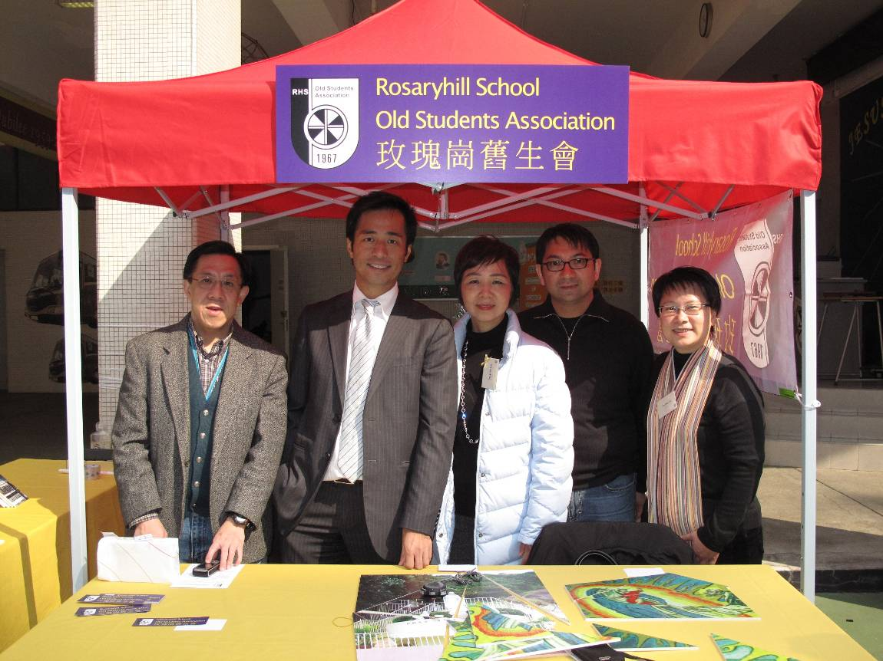
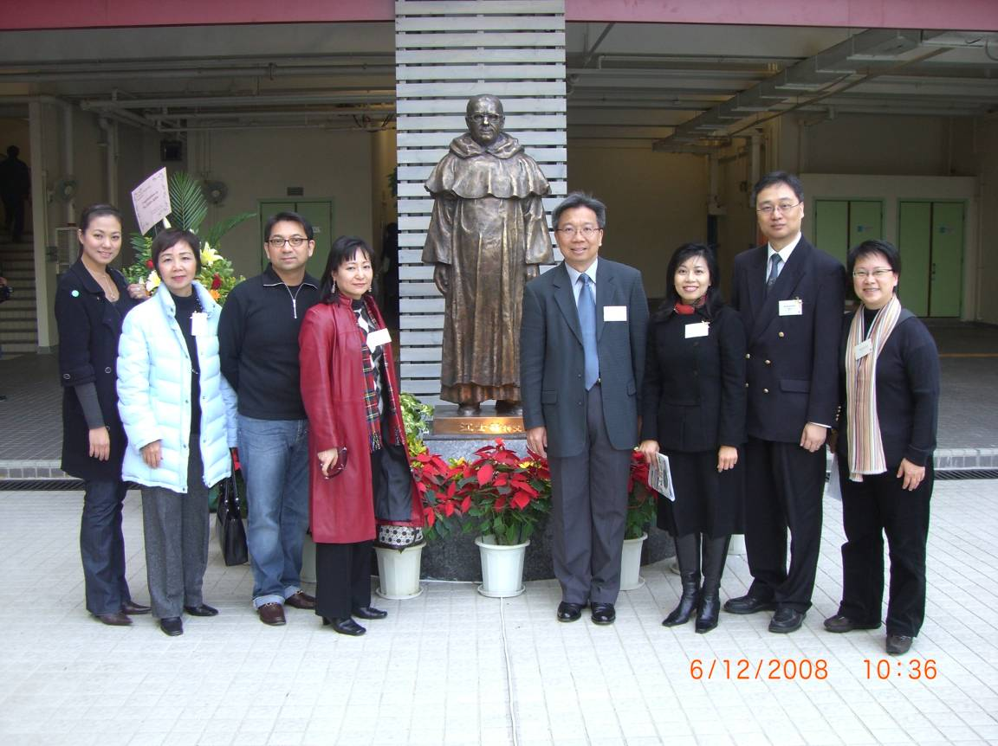
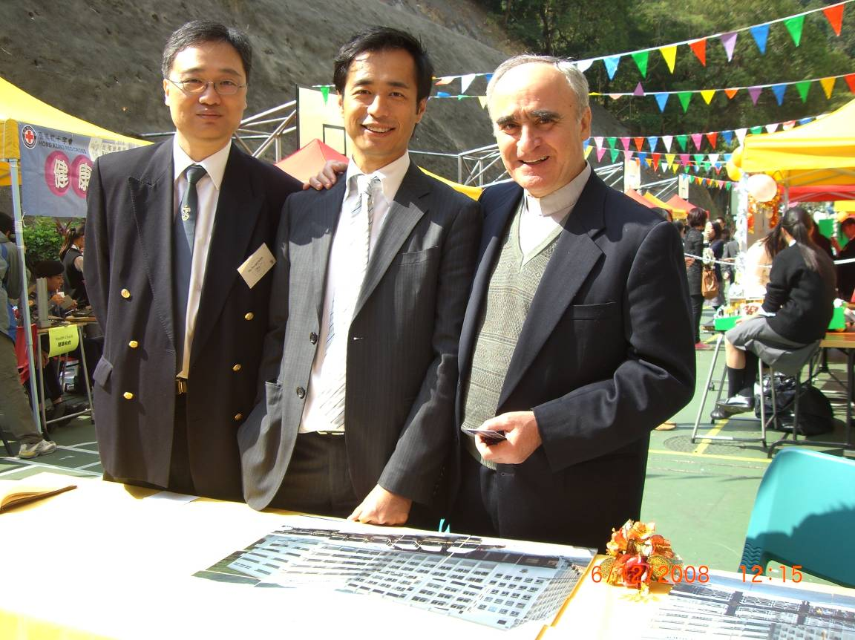
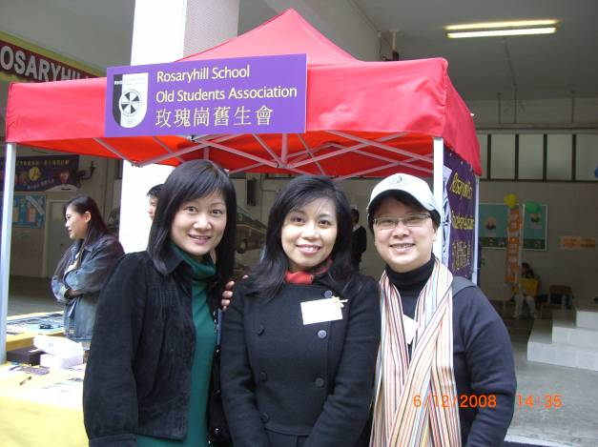

Golden Jubilee Open Day
In celebrating the School's 50th anniversary of Rosaryhill School, the school organized a Golden Jubilee Open Day held on the 6 and 7 of December 2008. The main activities of the open day include Opening Ceremony, Stall Games, Performances, Clubs and team demonstrations.
The unveiling of the statue of Fr. Eutimio Gonzalez, founder of Rosaryhill School, was held during the Golden Jubilee Open Day. Fr. Jose Sales, Acting Provincial, conducted the unveiling and blessing of the statue together with Mr. Bernard Chan Guest of Honour of the Open Day.
RHSOSA set up a tent with 5 very interesting jigsaw puzzle games. Many of the game participants finished the games within the time limit and got a RHSOSA souvenir - a RHSOSA 2009 calendar /book mark. On the 2 Open Days RHSOSA also successfully recruited more than 70 new members. Many thanks for your continued support and hope we see you again in our future activities in the future.

Page 4 of 6
Volume III/IV, 2008

Page 5 of 6
Volume III / IV, 2008

Annual General Meeting (AGM) cum Dessert Appreciation & Ball Games Competition

The next Annual General Meeting (AGM) cum Dessert Appreciation & Ball Games Competition will be held on Saturday, 28th February, 2009. At the AGM on 28th February 2009, you will have the opportunity to vote for the RHSOSA’s next president and the executive committee. If you are interested to participate in running for the offices of RHSOSA or there is someone you would like to nominate, please complete the nomination form (you can find the form in our website: www.rhsosa.org ) and return it to president@rhsosa.org on or before 21st February 2009.

Apart from the Annual General Meeting, RHSOSA is also organizing some other activities prior to the AGM in which you can get to learn how to make desserts or if you are a sportsman/woman, there will be badminton and basketball competitions. Prizes will be given to winners of the competitions.

Details of the above event are as follows:
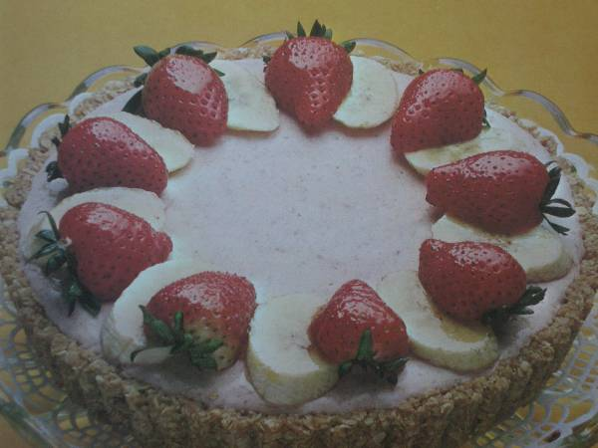
There will be 2 streams of event running at the same time before AGM, both starting at the same time:

2:15 p.m. – 3:30 p.m.:
Dessert Demonstration – by Ms. Angelina Ho and Mr. Wilson Kwok.
- Ms. Angelina Ho (RHS’ Panel Head of Home Economics) will demonstrate Banana Berry Chiffon Pie" - "香蕉草苺雪芳批
- Mr. Wilson Kwok (Our alumnus and a renowned Hong Kong gourmet, wine collector and restaurateur; will demonstrate Cream Puff with Ice Cream and Hot Fudge
Ball Games Competitions - Basketball and Badminton.
3:45 p.m. - 4:30 p.m.: AGM
4:30 p.m.: Prize presentation to the winners of the ball games competition.
4:30 p.m. - 5:30 p.m.: Refreshments

As we will have to make arrangements for the competitions, seats for the dessert demonstration and refreshments in due course, we appreciate if you could complete the registration form (you can find the form in our website: www.rhsosa.org ) and return it back to us at activities@rhsosa.org on or before 21st February 2009.

Should you have any questions, please contact us at activities@rhsosa.org or president@rhsosa.org.

We look forward to seeing you on 28th February 2009!!

Page 6of 6
Volume III/IV 2008

Lookout for the other 2009 Golden Jubilee Activities

There will be more Golden Jubilee celebrations to come, see below for the summary of the Golden Jubilee Activities.

Musical Gala
In celebrating Rosaryhill School Golden Jubilee, there is another big event in March 2009. A musical "Monte del Rosario: Mision y Escuela (Hill of the Rosary: Mission and School)" will be organised by the school and will be revealed in 29 March 2009 in the Jockey Club Auditorium of Polytechnic University. Look out for further information on our website or the school website.

RHSOSA Newsletter

Volume III /IV, 2008

The following is the Summary of the Golden Jubilee Activities

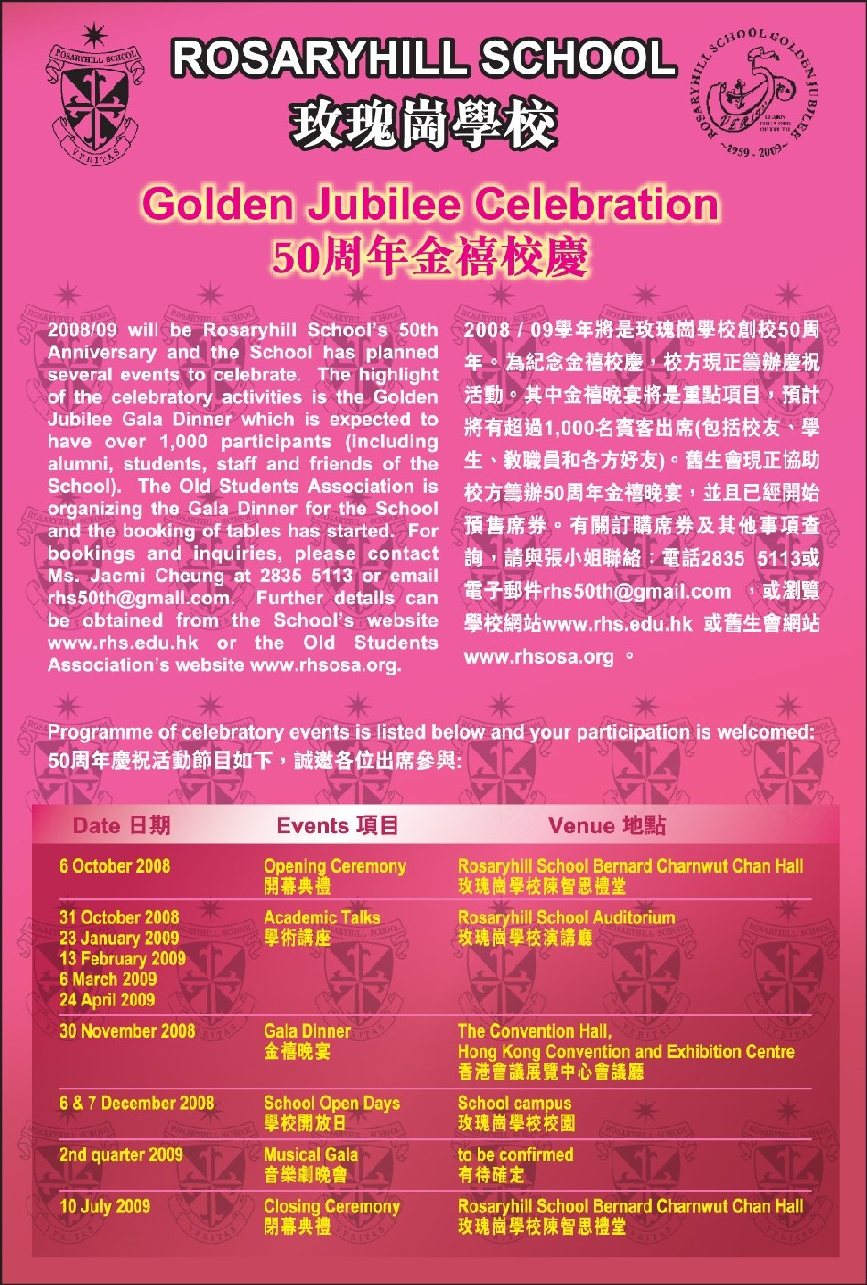

We’re on the Web!
See us at:
http://www.rhsosa.org
Rosaryhill School
Old Students Association

41B Stubbs Road, Wanchai,
Hong Kong.

Email:
editorial@rhsosa.org

Rosaryhill School Old Students Association
41B Stubbs Road, Wanchai, Hong Kong.
http://www.rhsosa.org

Editorial Board:
Patrick Rozario
David Chow
Edward Ng

Honorary Advisor:
Ms. Cathy Lau

