Rosaryhill School

Old Students Association

RHSOSA Newsletter

Volume II, 2008

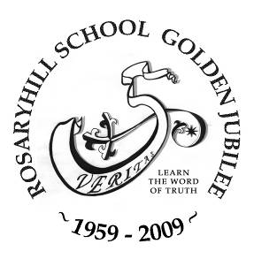
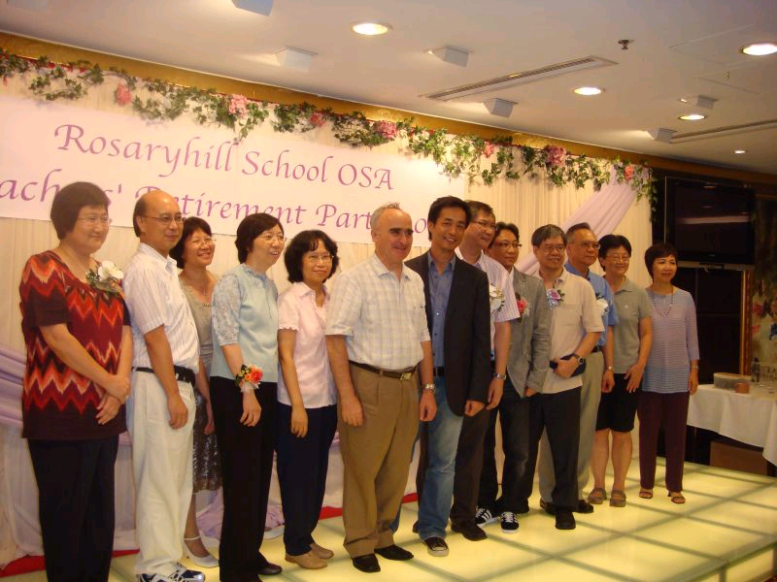
This issue:
- RHSOSA Teachers' Retirement Party 2008 (Page 1)
- An Interview with Ms. Leung Yee Wan, Principal, Primary Section (Page 2 to 3)
- 2008 RHSOSA Scholarship Awards (Page 4 )
- Join our November 's event – HK Heritage Tour – (Page 5)
- News and Events (Page 6)
RHSOSA Teachers' Retirement Party 2008

The RHSOSA Teachers' Retirement Party 2008 took place at 7pm on 5th July 2008 at King Palace Restaurant in Hopewell Centre, Wanchai.
All of the teachers in the secondary section who decided to retire after the end of this academic year came to the dinner. They are Ms. Betty Suen, Ms. Betty Hung, Mr. Lee Kwok Leung, Ms. Amy Lo, Mr. Pang Kim Ming, Ms. Elsie Kwan and Mr. Horace Luk (Biology lab technician). As well as Ms. Belinda Lam who had left RHS last year (She is now working at the Chinese University of Hong Kong).
More than 60 past students came to say farewell to our beloved teachers, many of who were 'new' faces of RHSOSA's organised events. Like all traditional Chinese dinner, of course you can hear the sound of Mah-jong before the dinner started. Over the evening, the past students had a great deal of opportunities to chats with their former teachers, to take photographs with them and to exchange contacts. Souvenirs were presented to the retiring teachers for the appreciation of their long service in RHS and their hard work over the years. On the other hand, souvenirs were also given to all of the past students by the retiring teachers to show their appreciation of the event.

RHSOSA's Teachers' Retirement Party 2008

Page 2of 7
Volume II, 2008

An interview with Ms. Leung Yee Wan

Ms. Leung joined the primary section of Rosaryhill School as the Head Teacher in August 2007. After one school year, she officially succeeded from Fr. Francisco as the Principal of the Primary Section in June 2008.

” Where there is love, there is everything.”
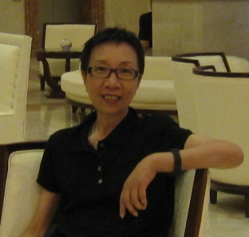
OSA: Ms. Leung, thanks for accepting our interview. Our alumni are interested in knowing you. Can you tell us your background?
Principal: It’s my pleasure. I had been the Principal of Canossa Primary School (San Po Kong) and Canossa AM Primary School. I retired from Canossa Primary School (San Po Kong) in July 2007.

OSA: What are the factors leading you to continue working?
Principal: I am a workaholic. I believe that I can continue to contribute to the education sector. Furthermore, I was grown up in Wanchai, so I know pretty well about Rosaryhill School. It would be interesting and challenging to apply my experience gained from the subsidised schools on a private school.

OSA: Do you mean that you don’t have any experience of working in a private school?
Principal: Not really. I started my teaching career as a teacher in Canossa Sacred Heart AM Primary School, which is a private school.

OSA: What is your philosophy and belief on education?
Principal: Having worked with the Canossa Schools for 27 yrs, I would say “LOVE” is my belief.

People will become better when there is love. Love to learn and love to know the world. Love your job and try your best. Love the people around you and learn from them;
Love yourself. Where there is love, there is everything.

OSA: What are the differences between Rosaryhill School and the other schools that you served before?
Principal: As a private school, Rosaryhill School, is more flexible and thus decisions can be made more promptly. Of course, a simple organisation structure also helps. Rosaryhill School is a large school with kindergarten, primary, secondary and business sections, and they are all under one Supervisor, this helps to resolve any conflicts. Furthermore, a private school has more flexibility in recruiting teachers and setting the syllabus. However, subsidised school has stronger financial support from the government, especially in information technology equipment and support.

A standard subsidised primary school has 24 classes and each class has 32 pupils. Even the so-called small class still has 28-30 pupils. Comparatively, Rosaryhill School has fewer students in each class and teachers can pay more attention to each student.

Teaching staff in Rosaryhill School is generally hard working, and willing to learn from each other. It’s a different culture from the civil servants. In terms of teaching medium, most subsidised schools use Chinese, but Rosaryhill School is bilingual.

In Rosaryhill School, we receive strong support from parents because they concern with their children. Parents also like to communicate with the school.

Page 3 of 7
Volume II, 2008

An interview with Ms. Leung Yee Wan (Continued)

In terms of the background of students, pupils from Rosaryhill School come from upper to middle lower, and they are pure and have better innovation. They are more willing to accept pupils of different nationality. The quality of our students is high because they have better visibility and are intelligent.

OSA: Over the past year of service, have you identified any strength at Rosaryhill School?
Principal: The infrastructure of Rosaryhill School is its strength. It has its own canteen and its fleet of school bus. Furthermore, the parental support to the school and pupils are strong. Our pupils are of high quality and creative.

OSA: Have you noted any areas needed to be improved? What are your recommendations for the improvements?
Principal: The world is changing everyday, and we have to keep pace with the changes. In the coming year, we have plans for development to our pupils, teachers, and parents.

For our pupils, the school will place more emphasis on discipline and initiatives. We would organise more activities for them to do their own thinking rather than just listening. Self-learning is the mode of learning in today’s world, and our pupils should be able to develop the skills of self-learning. Furthermore, we shall continue to strengthen our pupils’ capability in learning in both English and Chinese environment.

For our teachers, the school will offer more professional training for them to equip themselves for the new challenge.

For our parents, we encourage more communications between the school and parents for the benefits of the pupils.

OSA: You may note that from 2006 onwards the Old Students Association (“OSA”) gives out four scholarships to our primary six graduates – two top students in Chinese Language and two top students in English Language. Other than that, do you have any suggestions to the OSA to benefit our primary students?
Principal: Given that our alumni work in different professions, it would be great if the OSA can organise alumni to talk about their professions. Moreover, we hope that the OSA can provide technical or financial support on information technology to the primary section. Our equipment is getting old and it is time to think about major upgrades.

OSA: Do you have any words for our alumni?
Principal: Do the right thing at the right time. Never miss a chance to learn or to play. Network of people is very important for the future.
Love yourself first, so that you can love others.

OSA: On behalf of the OSA, I wish you enjoying your work.
Principal: Thank you.

Reporter:
David Chow, Form 7 Science, 1980

Page 4 of 7
Volume II, 2008

2008 RHSOSA Scholarship Awards

In June 2005, we launched the RHSOSA Scholarship Awards Programme for both Secondary Section and Kindergarten Section. From 2006, the same award was also offered to the Primary Section.
The objectives of the RHSOSA Scholarship Awards are
- to recognize students with outstanding achievement in their studies, in particular Chinese Language and English Language, and
- to promote and cultivate the learning of Chinese Language and English Language.

Details of the rules and regulations are available on the OSA web site. We are very delighted to announce the following 2008 award winners.

Constance Hui (left), Audrey Wong (middle) and Leonni Antonio (top) received their scholarship awards from
Ms. Helen Cheung, Events & Activities Director of the Rosaryhill School Old Students Association.

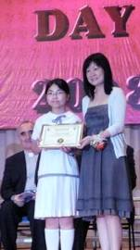
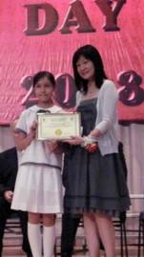
Scholarship award winners from kindergarten

Page 5 of 6
Volume II, 2008

Join our November's Event - HK Heritage Tour

After our last meaningful event, RHSOSA Teachers' Retirement Party, RHSOSA is back to enjoyable nature again! Please come join us by participating in our next event “Hong Kong Heritage Tour” on 2nd November 2008 (Sunday). During the trip you will get the opportunity to see the green side of Hong Kong as well as our own heritage culture. The itinerary of the tour is set out as follows:

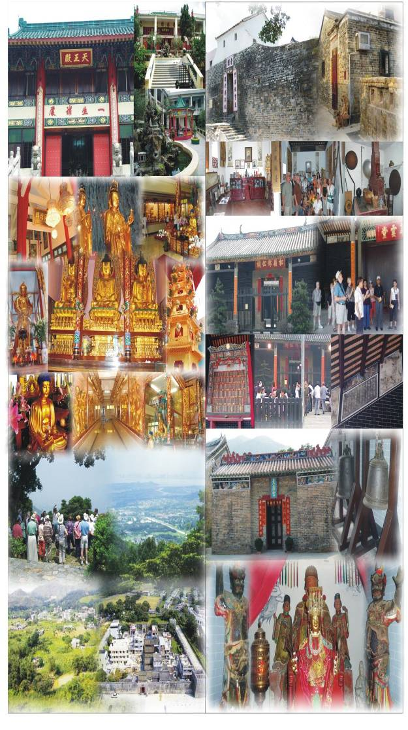 | Pickup at Central at 9am  - 500 Lohan Temple  - Bamboo Forest Monastery  - Route TWISK Look Out Point  - Tai Fu Tai Mandarin’s Mansion  - Tang Chung Ling Ancestral  - Tin Hau Temple  - Lo Wai (with a tradition Pun Choi lunch)  Tour is expected to finish at around 3:30pm

Fees: HK$280/head (including tour guide service, transportation and lunch)

If you are interested to join us to enjoy the beautiful countryside of Hong Kong during the comfortable autumn, please complete the registration form (you can find the form in our website: www.rhsosa.org ) and return back to us at activities@rhsosa.org on or before 21st October 2008.

Page 6of 6
Volume I, 2008

Lookout for the 2008 / 2009 Events and Activities

We are entering into the Golden Jubilee celebration of our School, see below for the summary of the Golden Jubilee Activities.

2008 AGM + Cooking Competition ……
By March 2009, it is time for the 2009 AGM. We hope the 2009 AGM can bring more fun to all of you, so we are planning to arrange other activities that our members could participate with their family. May be a cooking competition will be of interest to a lot of our members. Anyway, look out for further information on our website.

RHSOSA Newsletter

Volume II, 2008

The following is the Summary of the Golden Jubilee Activities

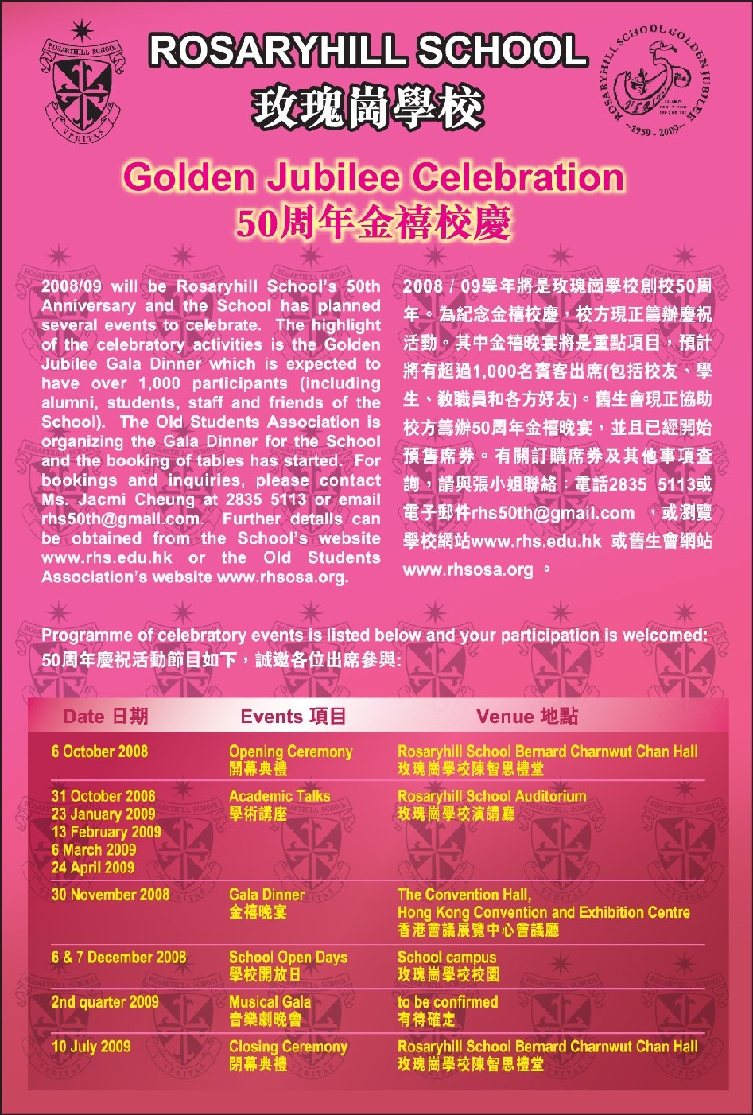

We’re on the Web!
See us at:
http://www.rhsosa.org
Rosaryhill School
Old Students Association

41B Stubbs Road, Wanchai,
Hong Kong.

Email:
editorial@rhsosa.org

Rosaryhill School Old Students Association
41B Stubbs Road, Wanchai, Hong Kong.
http://www.rhsosa.org

Editorial Board:
Patrick Rozario
David Chow
Edward Ng

Honorary Advisor:
Ms. Cathy Lau

