Rosaryhill School

Old Students Association

RHSOSA Newsletter

Volume I, 2008

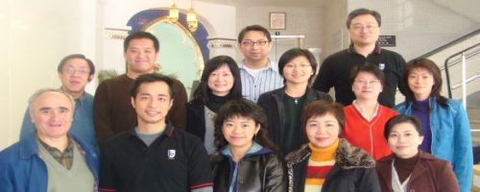
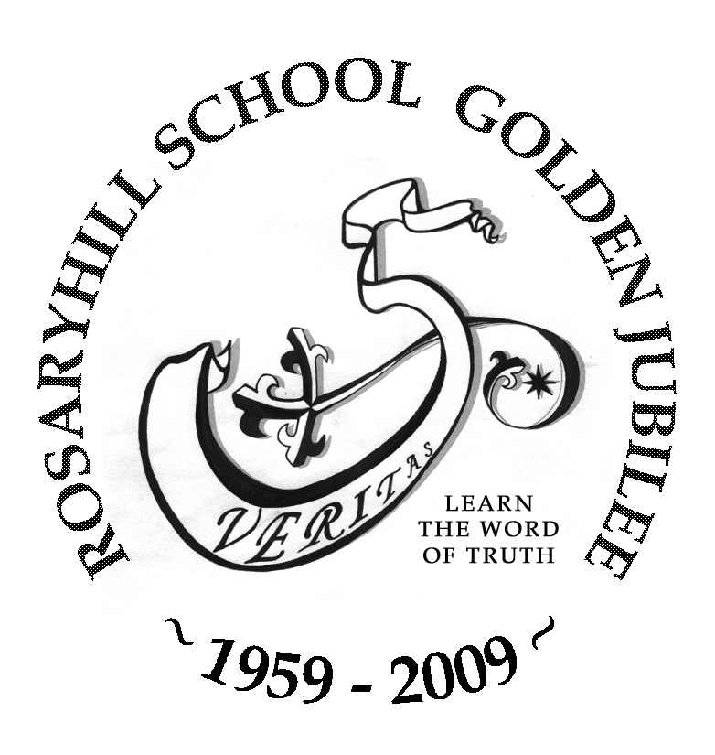
This issue:
- AGM cum Fun Fair Day 2008 (Page 1 to 2)
- An Interview with Ms. Edith Poon (Page 3 to 4)
- Rosaryhill School Golden Jubilee (Page 5 to 6)
- News and Events (Page 7)
AGM cum Fun Fair Day 2008

The Annual General Meeting (AGM) cum Fun Fair Day 2008 was held on Saturday, 1 March 2008. The event started at the Basement where 10 game booths were set up. Quite a number of our members came back with their children for the event, which all of our members and their children enjoyed the games very much. At 2:30pm we then proceeded to start our Annual General Meeting; however, we were just a few heads short for the quorum, so the meeting was adjourned for 45 minutes as required by the Constitution. During the adjournment, light refreshments were served and our members and guests enjoyed them very much especially most of the food were prepared by our committee and members.
The AGM resumed at 3:15pm and our president and treasurer, Edward Ng and David Chow, delivered a detailed annual report and financial report respectively and all of the members then unanimously approved the reports subsequently.

Meet the new Executive Committee

The following persons were elected to be executive committee for 2008-2009:
President: Edward Ng
Vice-President: Amy Chan
Treasurer: David Chow
Secretary: Raymond Lok

The new executive committee hopes you can continue to support the RHSOSA and participate in our activities! Plan of events and activities for the coming year is listed out on the last page of this Volume.
AGM was then followed by a Treasure Hunt which was eventually won by the team led by our former President, Eric Lee.

See next page for more photos of the event.

.

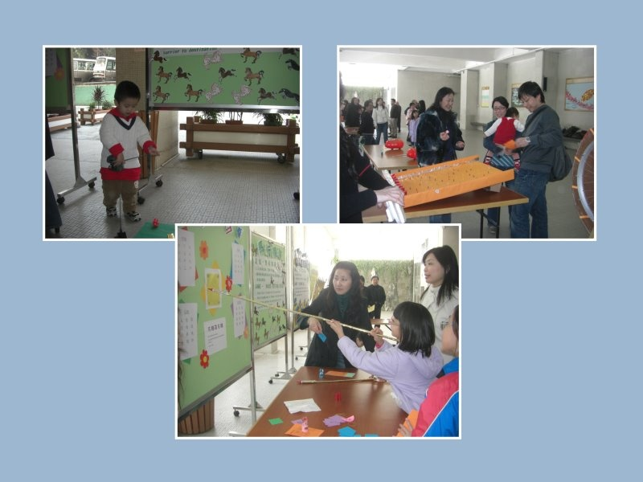
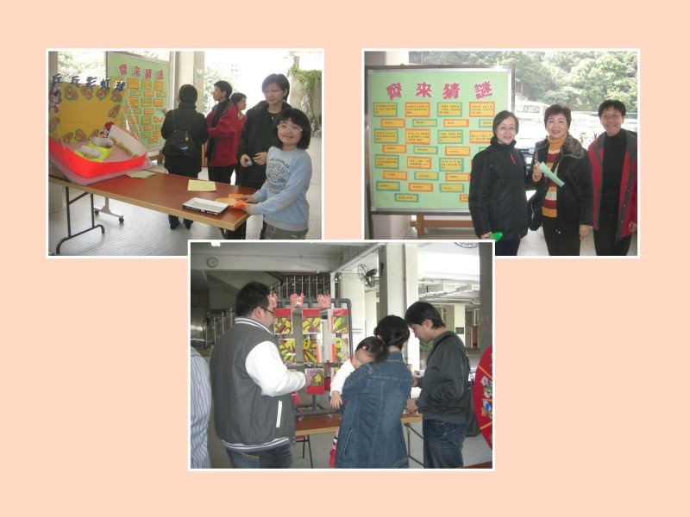
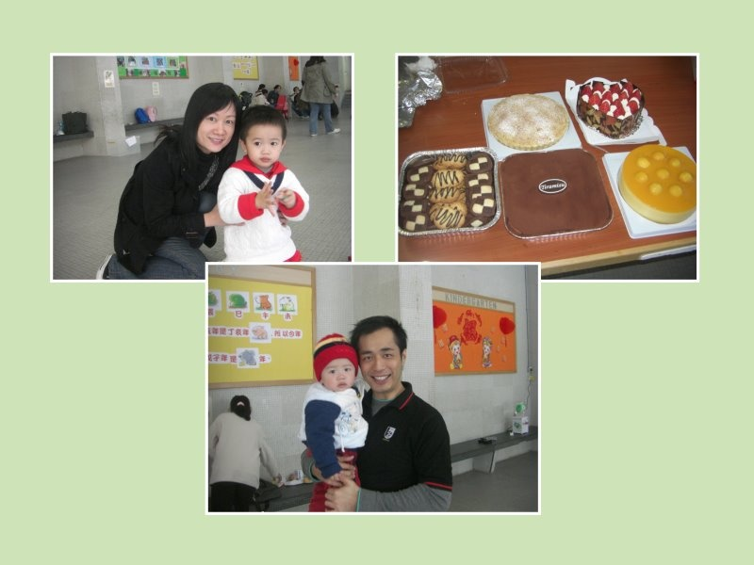
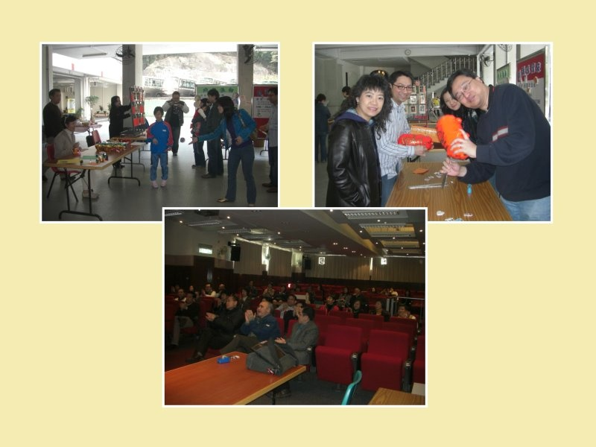
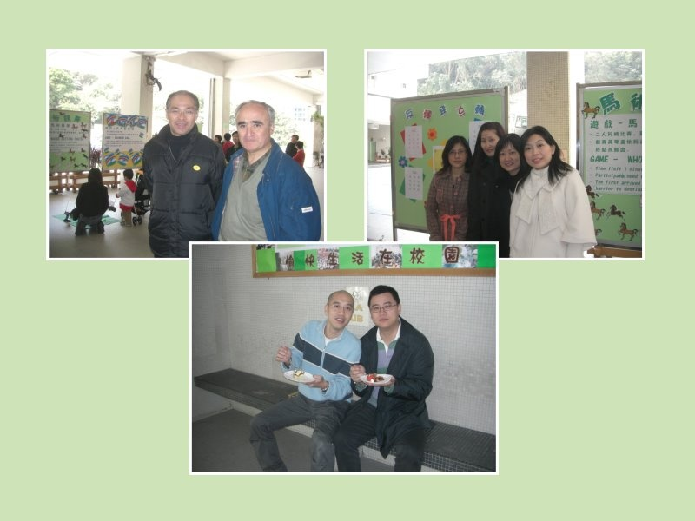
Page 2 of 7
Volume I, 2008

AGM cum Fun Fair Day 2008 – More Photos

Delicious cakes prepared by our President and other members

The AGM

Gaming as exciting as Macau

Page 3of 7

An interview with Ms. Edith Poon

Ms. Poon is no stranger to our alumni who graduated from the primary section of Rosaryhill School. She had been the Deputy Principal of Primary Section for many years and retired in last August.
Volume I, 2008

advertisement placed by Rosaryhill School, so I submitted my application letter. Luckily, I got the job.

OSA: Do you remember who interviewed you?
Ms Poon: Yes, I do. It’s Fr. Vincente. He looked like an angel from heaven.

OSA: Can you briefly describe your career path in Rosaryhill School?
Ms Poon: In the first year of teaching in Rosaryhill School, I was assigned as a class mistress. Fr. Francisco took up the post of Principal in the following year and I was assigned to be the Discipline Head of the afternoon session. At that time, primary students had half day school. In the third year, I was promoted to be the Deputy Principal of Primary Section.

OSA: It’s really quick to become a Deputy Principal. I’m sure Fr. Francisco appreciated your working capability. Some teachers like to have the duty of class mistress, but some don’t. Which one do you prefer?
Ms. Poon: A class mistress has close relationship with the students in the class. However, a Deputy Principal can reach out to students not limited to a particular class. No matter which class or grade a student is studying, a Deputy Principal can take care of the student. Indeed a Deputy Principal is more objective and can have an independent view as compared with a class teacher.

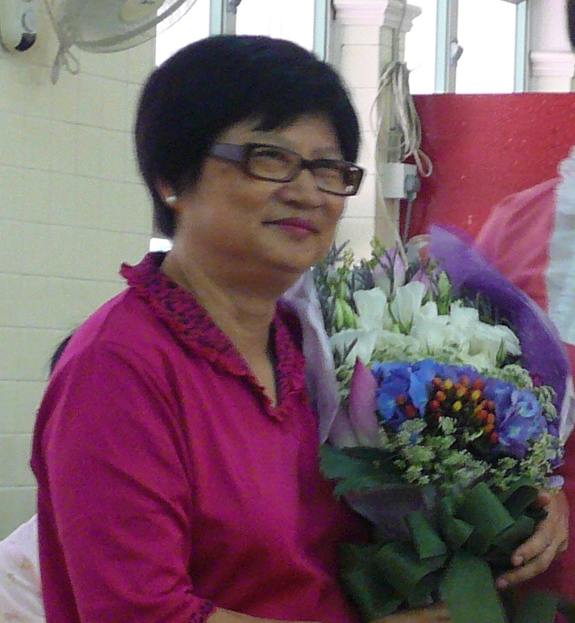
Ms. Edith Poon
”If you like to eat cakes, you should teach at Rosaryhill School.”
OSA: Ms. Poon, thanks for accepting our interview. Have you thought of teaching as your career when you were young? What is the influence to your decision?
Ms. Poon: It’s my pleasure. When I was a secondary student, one of my senior schoolmates influenced me a lot. I had thought of either being a social worker or a teacher because both occupations can help people.

OSA: In which year did you join Rosaryhill School? Is this your first teaching job?
Ms. Poon: I joined Rosaryhill School in 1981. Before teaching at Rosaryhill School, I taught at New Asia Middle School (新亞中學), a co-ed secondary school in To Kwa Wan.

OSA: What was the reason for you to come to Rosaryhill School?
Ms. Poon: It’s because of a piece of cake. One day my colleague gave me a piece of cake, it’s so delicious. She told me, ”If you like to eat cakes, you should teach at Rosaryhill School.” She explained that parents of the kindergarten students purchased so many cakes for the monthly birthday party. As a result, the surplus was shared among the teachers in the school. She always had cakes to eat because one of her family members was a kindergarten teacher of Rosaryhill School.

OSA: Is this true?
Ms. Poon: Not really. Indeed I quitted from work after I gave birth to my elder daughter. After one year, I started looking for teaching post again. Coincidentally I read an

Page 4 of 7

An interview with Ms. Edith Poon (Continued)
Volume I, 2008

OSA: Which subjects did you teach? What is your favourite subject?
Ms. Poon: I taught English, General Studies, Science and Arts. My favourite subject is English because I liked linguistics and to analyse sentences.

OSA: Regarding the students and parents of the 1980s and 2000s, do you observe any differences?
Ms. Poon: The students in the 1980s were more intelligent and more independent. On the other hand, I would say that the students in the 2000s are more knowledgeable, higher in height but too fat. As there are lots of temptations, students focus less on their studies and are living in a material world. Regarding the parents, the older generation parents preferred disciplined actions and paid more respect to teachers, but nowadays they changed.

OSA; Have you found that your character has changed over the years?
Ms. Poon: Yes. When I was young, I was a bit stubborn. Fr. Xavier changed my way of thinking, I gradually learned how to analyse things from different angles. As the age advances. I learn to accept people’s criticism.

OSA; I note that when you announced your retirement, many students cried. How can you earn such a high respect from them?
Ms. Poon: Love is the word. Nowadays parents are busy with their work and pay less attention to their children. I pay attention to each of my students, I care and love them, and from there I earn their respect.

OSA; What is your comment on the education reform and the impact to the primary section of Rosaryhill School?
Ms. Poon: It is a tough period for the school and the teachers. With the additional resources from the government, Rosaryhill School faces direct competition from government and subsidised schools. The teachers’ job priority has been inverted as they have to do a lot of administration work. The heavy administrative burden has used up teachers’ time in preparation for the class. The education reform does not bring any benefit to students because many experienced teachers have left the industry.

OSA: Can you tell us a few memorable events during your career?
Ms. Poon: The first one was the demonstration against the Tian An Men massacre. I worried about the traffic as the school bus could not send the afternoon session students home. The second one was the impact of SARS. The school had to purchase 5,000 masks for the teachers and students. The third one was about a primary two student who was slow in language development and from time to time hit his head to the wall.

OSA: What are your hobbies?
Ms. Poon: I like watching movies and Chinese opera and reading books.

OSA: Do you have any plan upon retirement?
Ms. Poon: I would like to travel and visit each of the provinces in China.

OSA: On behalf of the OSA, I wish you a happy and healthy life.
Ms. Poon: Thank you.

Reporter:
David Chow, Form 7 Science, 1980

Page 5 of 7
Volume I, 2008

Rosaryhill School Golden Jubilee – 1959 to 2009

A letter from Fr. Franciso de las Heras, Supervisor, Rosaryhill School about the Golden Jubilee's Gala Dinner.

28 January 2008 GOLDEN JUBILEE – GALA DINNER
To: All past students, parents and friends of Rosaryhill School
One of the highlights of the GOLDEN JUBILEE celebration is the GALA DINNER that many past students asked about even before we started planning the different events of the anniversary celebration. As you know from the information posted on the webpage, the main details for the dinner are:
Date: 30 November 2008, Sunday, 6:00 pm – 10:00 pm
Place: The Convention Hall, Hong Kong Convention and Exhibition Centre
But there is additional information that you all should have and it is time that we provide this to you.
- The Convention Hall accommodates around 85 tables of 12 persons each.
- The estimated cost of each seat – meal plus related expenses, is $750.
- We will have two non-paying VIP tables and some tables at a price below cost to cater mainly for those who may not be able to afford the full cost.
- There are tables at a price over cost, and the additional funds raised out of these tables would be donated to the school for these following purposes:
  - To subsidize the VIP tables and the ones below cost.
  - To subsidize part of other expenses of the GOLDEN JUBILEE, such as printing of a memoir, making of DVDs, production of a musical, academic talks, etc which I have previously mentioned in my communication to you.
  - To establish a GOLDEN JUBILEE SCHOLARSHP for students. The target of the scholarship is to award good student performance and to help deserving students with financial needs. Our objective is to raise HK$1.5 million for the scholarship. We have started working on the specific guidelines and the persons who will be in charge of the safe custody and award of the scholarship, and soon we will send further information to you all.

- Since Rosaryhill School is a Non-profit Making Organization, donations to the school are tax exempt. For those that pay the cost or less for the dinner, no tax exemption receipt is issued. The school will issue a regular receipt in acknowledgment of the payment for dinner. For those that pay more than the cost, i.e. more than HK$750 per seat, an additional receipt for tax exemption purposes will be issued for the amount in excess of the cost – the donation amount.

Page 6 of 7
Volume I, 2008

- All payments should be made in HK$ to ROSARYHILL SCHOOL – GOLDEN JUBILEE. For those residing abroad, please make arrangements to pay in HK$. Any foreign currency payment sent to the school will entail considerable bank charges and much delay in cashing. We trust that you understand the difficulty but if you are unable to make HK$ payment arrangements, please contact us and we will direct you to alumni co-ordinators who live abroad (mainly Canada and the US) who will assist if they are able to.
- Together with this notice we are posting the different pricings of the tables. Some tables have already been reserved before we make this official announcement. However, there are still enough tables left for us for now.
- For those who have already booked their tables, you need to support the booking with the payment by 15 April 2008. For tables booked after 15 April, payment should be made within two weeks after the booking, otherwise the booking will be cancelled and the table/seat made available for other “Rosarians”.
- Although we prefer for us to group ourselves together and take entire tables, if you are unable to do so, we do accept booking for individual seats for mixed tables.
We are really looking forward to seeing over 1000 teachers and past teachers, students and past students, parents and other friends of the school at the dinner. It could be a very memorable occasion for all, leaving lasting memories in all of us. Groups of old students are even planning to make the 30 November 2008 a ROSARYHILL SCHOOL day, coming to school in the morning in school buses for Mass and having lunch at the school canteen, etc. This is yet another idea for the GOLDEN JUBILEE!
I take this opportunity to thank those who have helped so much in preparing this Gala Dinner and other GOLDEN JUBILEE events. I am sure that their good work will not be in vain.
May God and Our Lady of the Rosary bless us all.
Fr. Francisco de las Heras
Supervisor

Page 7of 7
Volume I, 2008

Lookout for the 2008 / 2009 Events and Activities

This is an exciting year, other than all Golden Jubilee events (See below); RHSOSA will organize a number of activities in the next 12 months. Please look out for the information update in our website

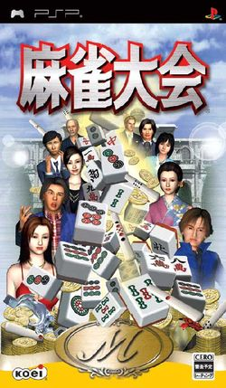
Summer Gathering
RHSOSA plans to organise a Mah-jong competition, a Monopoly or Apple Chess competition for the non Mah-jong players together with a dinner to celebrate the retirement of a few teachers in the evening of 5 July 2008 (Saturday).

RHSOSA Newsletter

Volume I, 2008

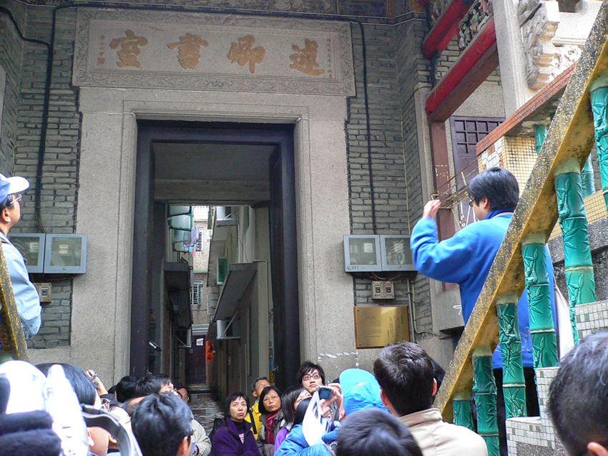

2008 AGM + Cooking Competition ……
By March 2009, it is time for the 2009 AGM. We hope the 2009 AGM can bring more fun to all of you, so we are planning to arrange other activities that our members could participate with their family. May be a cooking competition will be of interest to a lot of our members. Anyway, look out for further information on our website.

Heritage Trip
In the fall, we plan to organize a heritage trip to the Tang's village in the New Territories plus a Hakka meal. The trip will be held on 25 October or 1 November.
We’re on the Web!
See us at:
http://www.rhsosa.org
Rosaryhill School
Old Students Association

41B Stubbs Road, Wanchai,
Hong Kong.

Email:
editorial@rhsosa.org

Rosaryhill School Old Students Association
41B Stubbs Road, Wanchai, Hong Kong.
http://www.rhsosa.org

Editorial Board:
Patrick Rozario
David Chow
Edward Ng

Honorary Advisor:
Ms. Cathy Lau
The following is the Summary of the Golden Jubilee Activities

